Robot Trains in the Garden
d. bodnar revised 4-18-2004 4:00 pm

Introduction
I have only been actively involved with garden railroading for a little over one year but have found it to be a wonderful way to use the skills and interests that I have developed over the years in other hobbies. For example, I used my love of woodworking to help me design and construct two scratch built bridges and nearly 100 trestle bents to support much of the 200 foot main line on the railway. My interests in photography, computers and web pages allowed me to document the work on the railway and share it with my friends and family, wherever they may live. (see: http://www.davebodnar.com/railway/ )
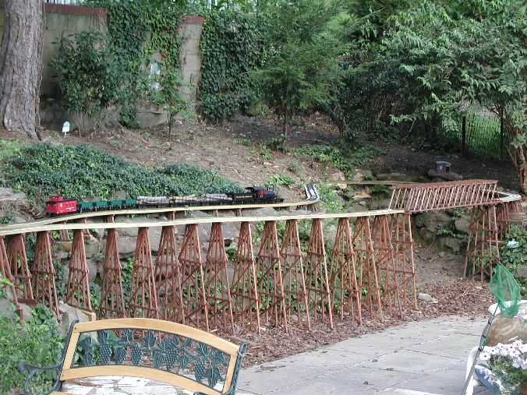
My latest collaboration between hobbies involves using my work with programming small, single board microprocessors and using them to control devices and sense things around them. For many years I have worked with small Basic Stamp microprocessors (see: http://www.parallax.com/ ). I have used the Basic Stamp to sense and react to temperature changes, monitor and control the charging of batteries, record the acceleration of model rockets and to operate small, autonomous robots. This project is a logical extension of my work with robotics as it involves using a similar microprocessor to control a battery operated railroad engine. The system is designed to have the engine slowly accelerate from a complete stop and then cruise at a preset speed until it passes over a magnet located on the track. When this happens a reed switch closes and the microprocessor gently slows the engine to a full stop. After a short pause the engine reverses and starts up again until it passes over another magnet when the process repeats.
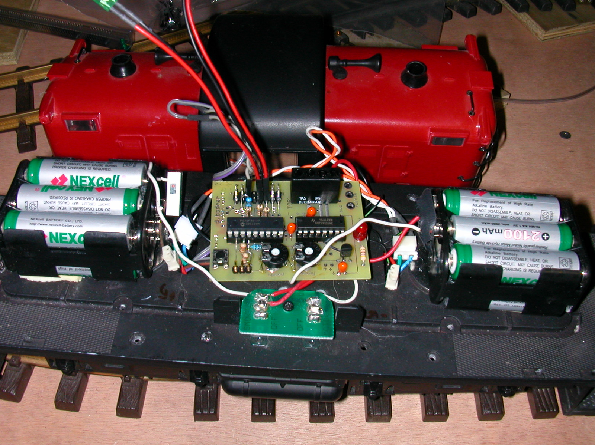
Although the original objective of the system was the auto-reverse system as described above, the hardware is capable of much more sophisticated operation by modifying the software. It could, for example, have a train start off and pause any number of times at various locations identified by magnets in the track. In conjunction with another microprocessor and controller it could also cause turnouts to switch so that the train could follow a different route. The only limitation is one’s imagination. (In the event that your imagination is suffering from a long, cold winter I have some ideas at the end of this article!)

Having spent many years writing lesson plans for my classroom I always start off projects with a set of objectives.

Objectives
- The engine will be able to accelerate and decelerate smoothly, run at a constant speed, stop and sense its location on the track
- The engine will operate from batteries
- A microprocessor will control the train’s motion
- The microprocessor will must use interrupts to detect crossing over a magnet so that no magnet crossings are missed
- All motor control will be solid state using an “H-Bridge”
- Motor speed control will be by PWM (Pulse Width Modulation)
- It will be possible to change some settings without reprogramming
- Programs will be easy to create and revise

Battery Operation
I have begun to switch much of my railway over to battery power. Battery operation simplifies this particular system by allowing all electronics to be housed in the engine. It also allows us to ignore problems that arise when entering switchbacks and wye’s and allows us to run multiple engines on the same line. NiMH batteries are used as they provide the most economical rechargeable power source. A total of 12 AA cells provide 14.4 volts and should power a small engine for several hours.

Microprocessor Operation
Although most of the objectives for the project could be met by creating a circuit using discreet logic and timer integrated circuits the overall flexibility and design is simplified greatly by the use of a microprocessor. Changes can be made in seconds with a simple program modification rather than needing to rewire or add components to a circuit.

The choice of microprocessor is always a challenge. The most popular small programmable system is the Basic Stamp by Parallax. Unfortunately the two most common “stamps” do not have interrupt capability. The most inexpensive unit that supports interrupts costs nearly $80.00. A new entry into the hobby microprocessor market is the PICAXE from Great Britain. There are a number of different styles. The 18X has all of the hardware capabilities that are needed at less than one forth of the cost of the Stamp.

Interrupts
Interrupts are something that we use on our computer every day. Whenever we use a mouse on a PC we are using interrupts. An interrupt simply tells the microprocessor that something very important is happening and that it must “interrupt” everything else that it is doing so that it can deal with that special event. When you move your mouse it is very important that the PC not miss that movement. An interrupt is generated that stops other things, moves the mouse cursor and then returns to its other obligations. Our system has one very important event that can’t be missed. The microprocessor must catch every magnet crossing. The best way to insure this is with interrupts. Without interrupts, if the microprocessor is busy resetting the motor speed when a magnet is crossed it is possible that it would miss that event. Interrupts do a great job of making sure that does not happen.

Motor Control
There are several ways to control the direction and speed of an electric motor. A double pole / double throw switch (or relay) can be used to change the direction of rotation by switching the + and – terminals providing power to the motor. Speed can be adjusted by using switches or a rheostat to introduce different resistances into the circuit. The more the resistance, the slower the motor spins. Unfortunately the energy that the resistance takes from the motor is dissipated as heat, something that can be difficult to get rid of, to say nothing about being inefficient!

Solid state motor control can be accomplished with a number of different devices that simulate the operation of a double pole double throw switch. The easiest to use and interface to a microprocessor is called an “H-bridge’ due to its internal arrangement of transistors in an “H” pattern. A typical “H-bridge” has three control pins. Two of the pins determine the direction of rotation and the third is used for speed control. By applying the right sequence of controlling pulses to these pins the motor speed and direction can be set. Some heat still must be dealt with, but the overall system is much more efficient, something that is especially important when working with battery operated equipment

Pulse Width Modulation
The objective that identifies PWM for speed control is part of the solid state motor control objective. When the microprocessor needs to change the speed of the motor it sends a series of pulses, called Pulse Width Modulation, to one of the “H-bridge” pins. This pin spins the motor at full speed if it sees 5 volts and stops the motor if it sees 0 volts. A voltage between 0 and 5 volts gives a speed proportional to the voltage. Microprocessors generally don’t deal well with variable, or analog, voltages. That is where PWM comes in. PWM sends a series of pulses of 5 volts to a pin to simulate a variable voltage. For example, if it sends pulses that are on ½ of the time the pin appears to have 2.5 volts on it. Sending pulses that are on 25% of the time looks like 1.25 volt and so on. (see graphic)

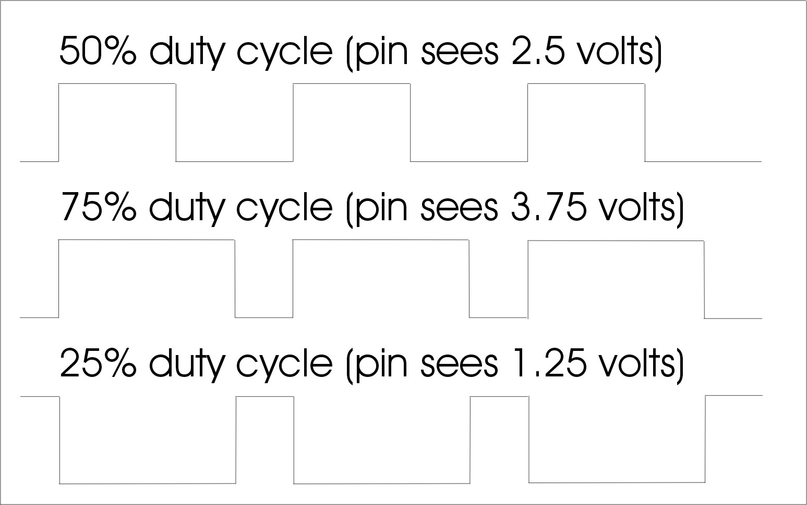

Changing Settings with ADC
This project has a number of settings, or variables, that change the operation of the engine. Among them are the top speed setting, the rate of acceleration and the length of time to delay when the engine pauses between direction changes. While we could reprogram the microprocessor to change any or all of these settings that can be inconvenient when you are in the garden and don’t have a laptop handy! To make changes, several potentiometers (variable resistors, often called “pots”) have been included in the design. A potentiometer is a fixed resistor that has a movable wiper that can slide along the fixed resistor to provide a continuously variable resistance between zero ohms and the full value of the fixed resistor. Our microprocessor has the ability to do Analog to Digital Conversion (ADC). If we hook one end of the fixed resistor to 5 volts the other to ground and one of the input pins of the microprocessor to the wiper on the pot the microprocessor will see a variable voltage between 0 and 5 volts as the wiper moves across the fixed resistor. ADC converts this value to a number, usually between 0 and 255. Once we have that value we can use it to control speed, time delay and other settings. (see graphic of a section of the schematic showing one potentiometer connected to ground, +5 volts and pin 1 on the Picaxe)

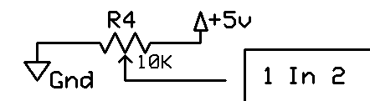

BASIC Programming
The last objective may be the most important. There are a number of microprocessors that meet the first set of objectives but they use specialized and highly complex programming languages that are not easy to learn and master. The PICAXE family of microprocessors uses a version of the well known BASIC programming language. BASIC uses easily understandable commands and is a language that many people have already experienced. The programming tools to write, debug and send programs to the PICAXE are easy to use, run on nearly any Windows PC and are a free download on the Internet. Download it from http://www.rev-ed.co.uk/picaxe/ - click on Software and download the full program.

The Circuit
The schematic is a graphical diagram of each of the parts that make up this project. As you can see there are two ICs (Integrated Circuits), the Picaxe and the LM293D “H-bridge” and a number of other parts that tie the whole thing together. Spend some time familiarizing yourself with the schematic as it will be a great tool if you are in doubt about how to attach a part to the circuit board or if you are building the circuit on your own project board.

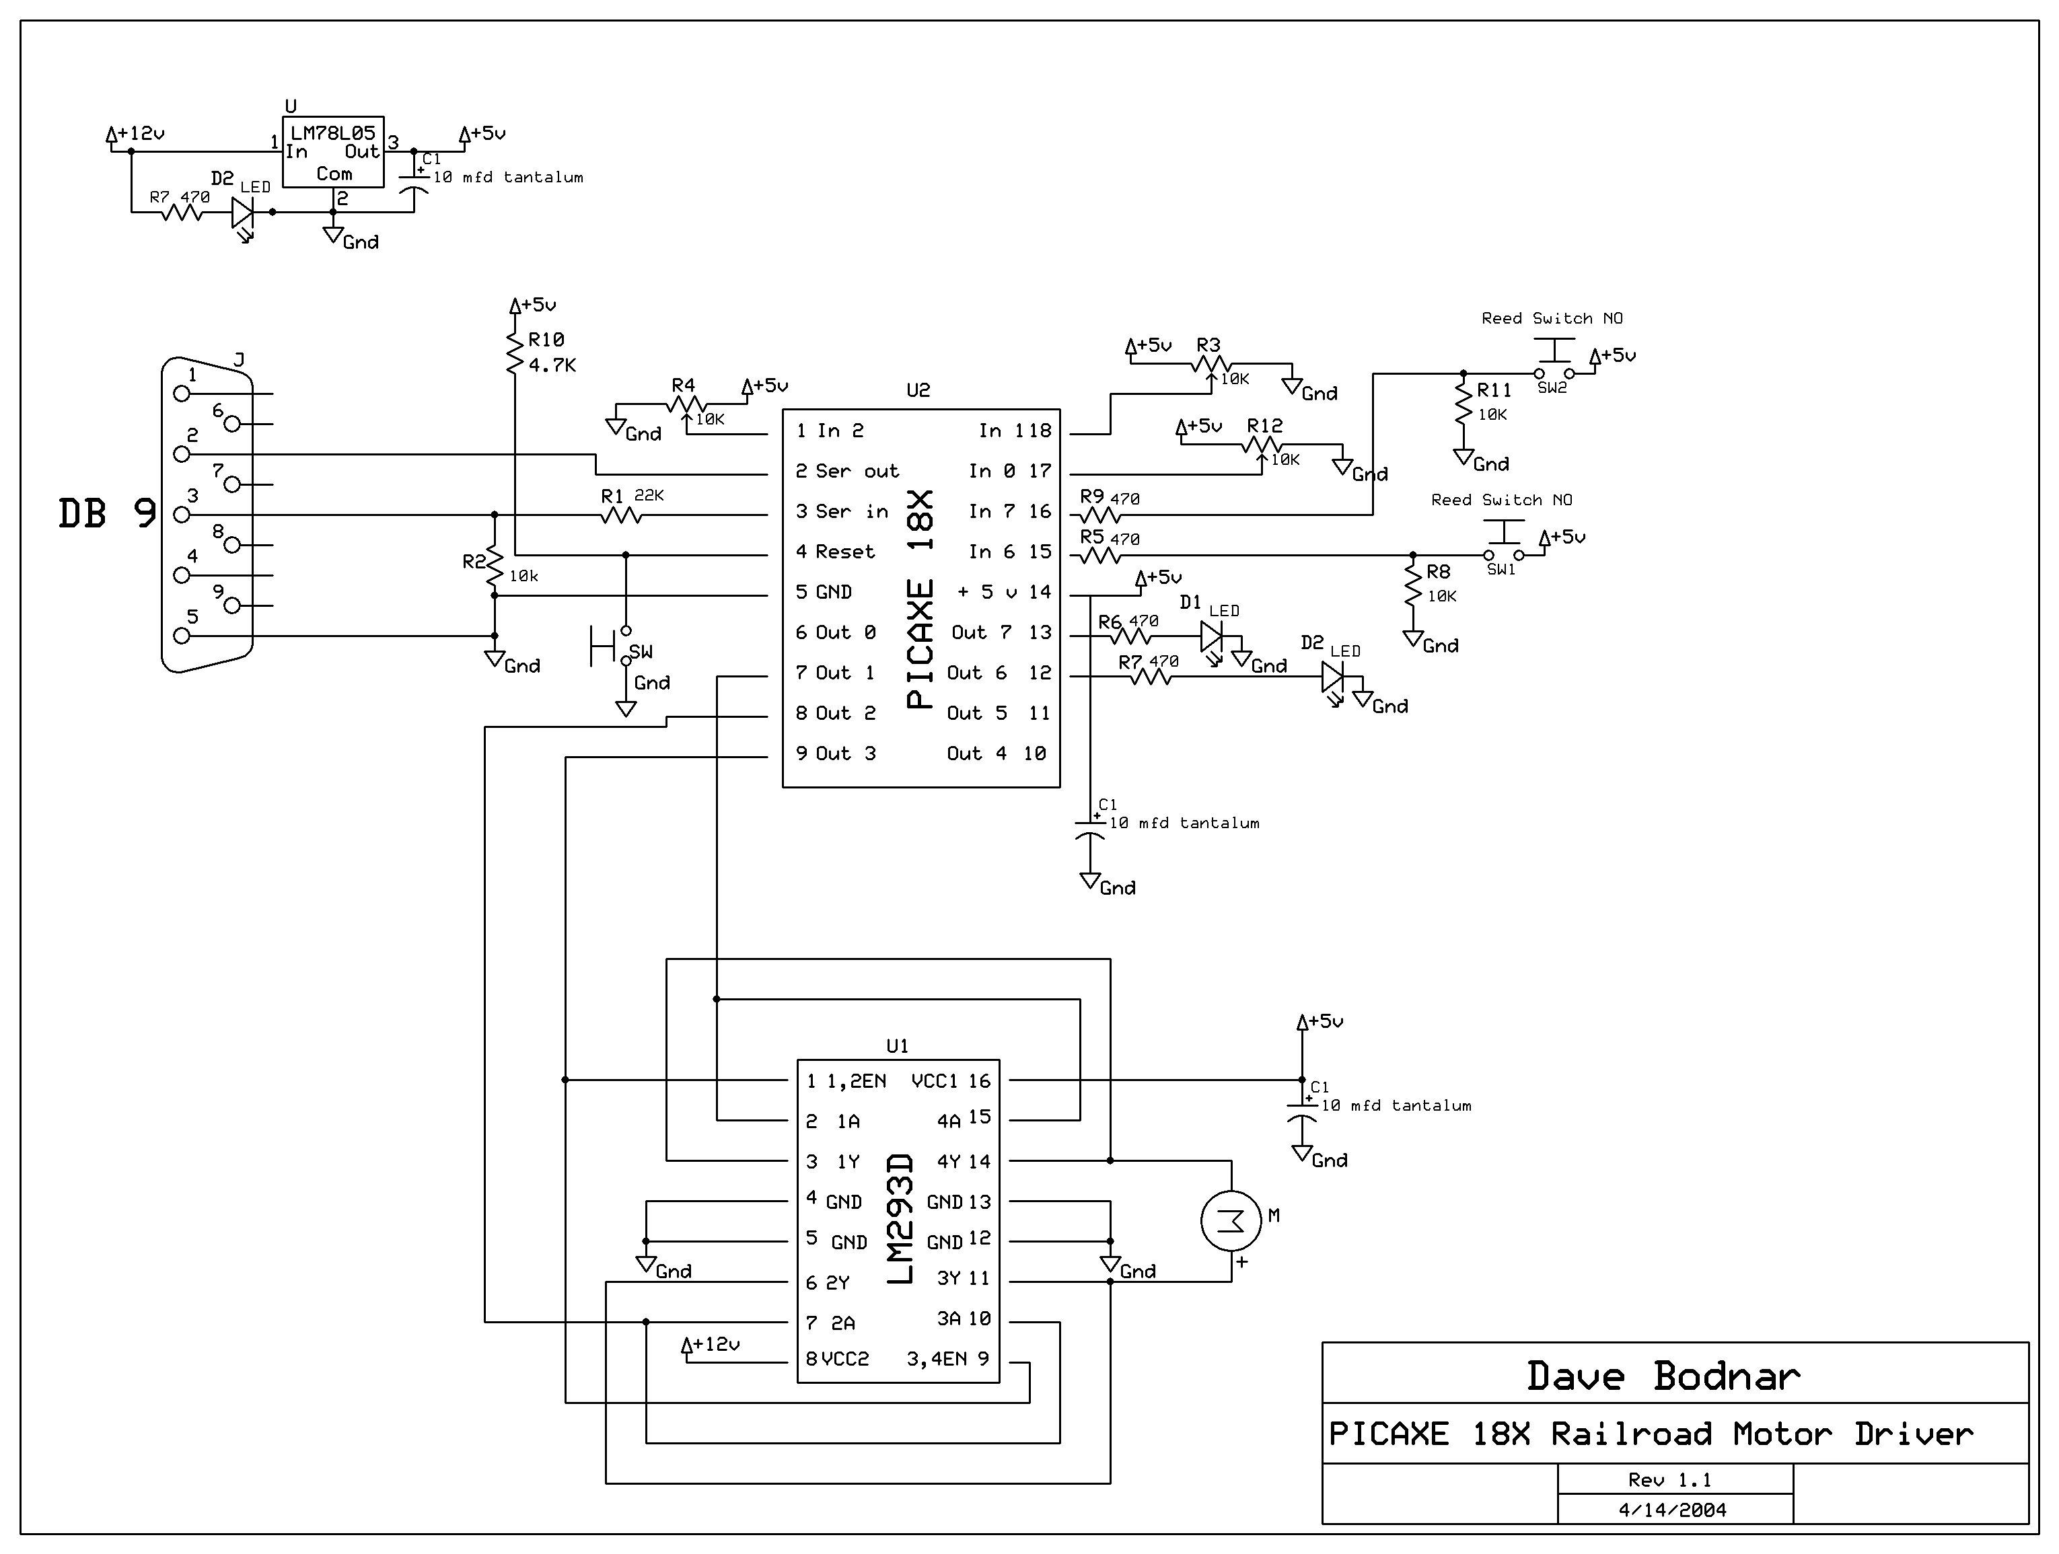

Parts list
- Microprocessor - PICAXE 18X
- H-bridge - LM293D or sn754410ne
- Voltage regulator - 78L05
- Resistors – 470 (7), 4.7K (1), 10K (3), 22K (1)
- Potentiometers – 47K (2 or 3) – the value is not critical – anything from 10 K to 100 K should work
- Capacitors – 10 mfd tantalum (3)
- IC Sockets – 16 pin (1) and 18 pin (1)
- LEDs – color is not important (3)
- Switches – SPST (1) for power, SPST momentary (1) for reset
- Reed Switch – small with normally open contacts (1)
- Magnets – high strength (2 or more)
- DB9 / Female connector (1)
- Fuse or circuit breaker (1)
- Circuit board (1) – prototype board or custom board
- Wire, other connectors as needed for your installation

Parts
- Note: I have nearly all of the parts used in this project, including the circuit board and completed & tested boards, available. Please send me an email (dave@davebodnar.com) for a price list.
- The Picaxe 18X microprocessor is an 18 pin integrated circuit. It is available directly from http://www.rev-ed.co.uk/picaxe/ .
- The H-bridge motor controller that was used in the prototype is LM293D. It has two complete H-bridge controllers on one 16 pin integrated circuit. Each can provide .6 amps to the motor. If we wire the two H-bridges together this chip can provide 1.2 amps of power. That should be more than enough for a small engine or trolley. While doing research on for this project I came across a “pin compatible” IC by Texas Instruments, the sn754410ne, that is a direct replacement for the LM293D. It supplies double the current, over 2 amps when the two H-bridge circuits are wired together in parallel. This should provide enough power for larger engines, even if they are pulling a few cars or going up a grade. If heat becomes excessive the chip will shut down until it cools. A heat sink and/or fan can be added if this becomes a problem. Both chips are available from http://digikey.com/
- The two chips we are using require a stable 5 volt power source. The 78L05 is a voltage regulator that can provide a regulated 5 volt output when supplied with a voltage from about 6 to 20 volts. Note that this is not a standard 7805, but a smaller device in a package that looks like a normal transistor. Also from http://digikey.com/
- Resistors are ¼ watt and are available from your local Radio Shack
- Potentiometers values are not critical. Just about any value from 10 K ohms to 100 K should work. Make sure you get “linear taper” not “audio taper” pots. The “audio taper” does not provide a linear change in resistance between one end and the other. Note that there is space on the circuit board for the pots but that it might be better to mount them off the board so that they can be turned from a convenient place on the engine. These parts are also available from Radio Shack
- The capacitors are used to keep electrical “noise” from the motor from getting to the microprocessor. If they are not used or are not the right value the microprocessor can give very unreliable, random operation that will drive you crazy! Almost all of the problems I have had with this system were traced to incorrect or insufficient noise suppression. See the troubleshooting section for more information about clearing up “noise”. 10 mfd tantalum caps work well and are available from http://digikey.com/ and other parts suppliers.
- IC sockets are not absolutely necessary as you can solder the two chips directly to the board, but they are inexpensive insurance against overheating the chips while soldering. They also make troubleshooting easier as you can test with the chip in or out of the circuit. Radio Shack carries them.
- LEDs are used for providing feedback from the system that lets us know what is happening. Since they are powered directly from the output pins on the microprocessor it is best to use standard LEDs, not the fancy high output ones as they can draw more power than the microprocessor can provide. They are available from most parts supply outlets and Radio Shack.
- The SPST power switch can be either on the board or externally mounted on the engine or battery pack. Holes are provided on the circuit board if you want to mount it there. Notice that you must cut a trace on the bottom of the board (marked with an arrow) for the switch to work.
- The SPST momentary switch is optional and provides a quick reset of the microprocessor. This can be handy to restart the program. It is optional as turning the system off/on does the same thing.
- A reed switch is used to sense a magnet on the track When I was working on the design I considered using solid state devices, Hall Effect sensors, to tell the microprocessor when it had passed over a magnet. I opted, however, for the simpler and less expensive reed switch. Reed switches are extremely reliable and can be found in burglar alarms and bicycle speedometers. To give you an idea of reliability, the reed switch connected to the speedometer of my road bike is turned on/off over 700 times for each mile of travel. I computed that it operated over 4 million times in the 6000 miles I logged last year. More importantly, in my years of cycling I have never had a reed switch fail!
- Magnets are used to stimulate the reed switch. I have been using small (¼” diameter x ¼” high) neodymium magnets. They are very powerful and can be placed inconspicuously on the track. Radio Shack has similar magnets.
- The programming cable that connects the computer’s serial port and the microprocessor can be made in a number of ways. I have opted to use a simple 3 pin header on the circuit board. This setup requires a matching female connector that is wired to a standard, female DB-9 serial connector. The female 3 pin connector that fits over this header can be hard to find. If you have an old PC sitting around the power cable for a 3.5” floppy drive has 4 properly spaced pins. You can cut one of the 4 sections off to make a three pin connector. I have made up some of these cables if you would rather not make your own. Note that the cable that is available from the Picaxe folks is a 1/8” stereo plug / jack combination that is not compatible with what I have used as it will not fit directly onto my circuit board.
- A fuse or circuit breaker must be included in the circuit. It is best to locate it in series with the positive lead from the battery pack. Space is not provided on the board for this device as it is most effective if it is located close to the battery pack.
- I have used two different types of headers to provide for easy connection of LED’s, the reed switch, power and motor leads. They are optional as the wires can be directly soldered to the board. These connectors are available from http://digikey.com/

Tools
- Soldering Iron – be sure to use an iron that has a low wattage (25 watts maximum) and a very fine 1/8” or 1/16” tip. The pins on the ICs are 1/10” apart and are difficult to solder with a larger tip.
- Solder – make sure you use solder that is designed for electronics use. NOT ACID CORE solder!
- Volt / Ohm meter – any simple meter will do if it can measure DC voltage up to 20 volts and resistance up to 100 K ohms. Radio Shack carries a number of meters for as little as $20.00.
- Wire – I use insulated 22 gauge wire for hooking up electronic components and heavier wire (18 gauge) for power connections to batteries and motors.
- Side cutters – used for cutting wire and clipping leads that have been soldered to the circuit board.
- Magnifying glass to check for good solder joints and solder bridges and short circuits

Prototype Construction
My first prototype for this project was hand wired on a Radio Shack circuit board (276-150). If you want to go that route the photos, parts list and schematic should be all you need. I built 4 circuits that way and found that each one took several hours to build and troubleshoot. Stripping and soldering tiny pieces of wire can be a bit of a challenge.

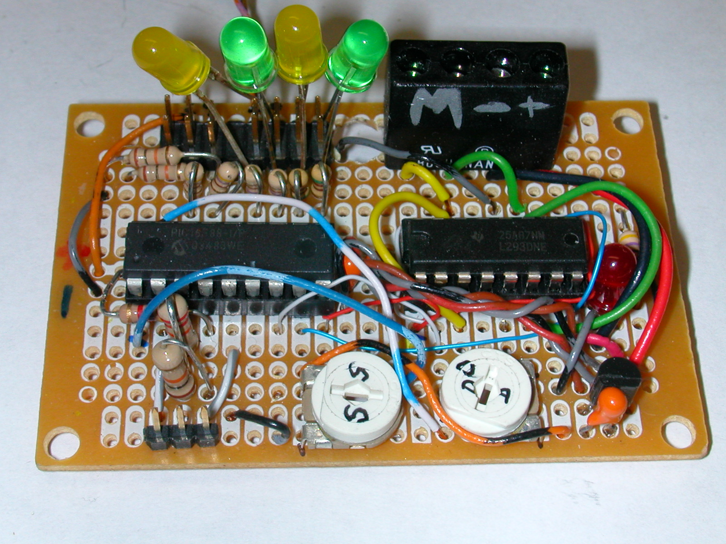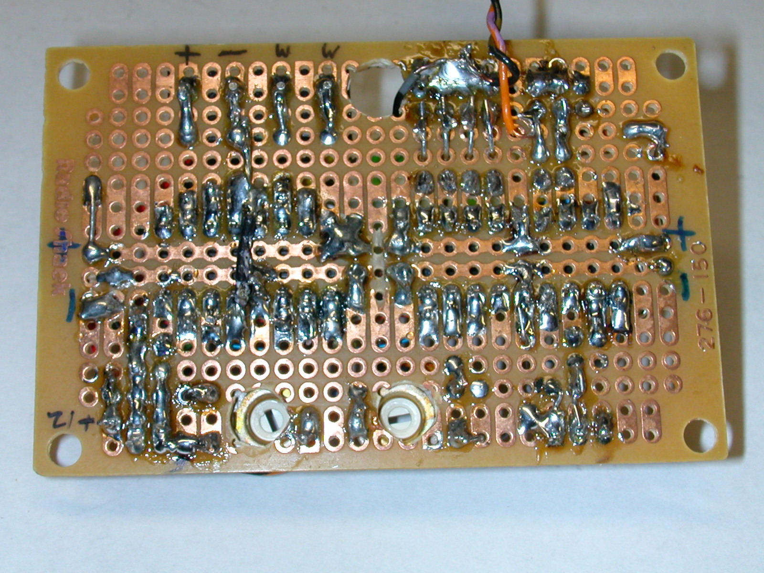
Custom Circuit Board
After getting the prototypes working well I came across a company that would make small batches of custom printed circuit boards. (see: http://www.expresspcb.com/ ) Their web page boasted free software for designing schematics and the circuit boards. After a few hours of experimentation with their software I sent off the initial plan for the circuit board. In three days I had boards in hand. I found that the construction time was cut by more than half and troubleshooting was almost unnecessary! Even more important they looked much better, almost professional! I have a few of these boards on hand and most of the parts. Please contact me by email if you would like to order any or all of these items. I also have a few completely wired and tested boards for those who are not able or interested in building this circuit from scratch.
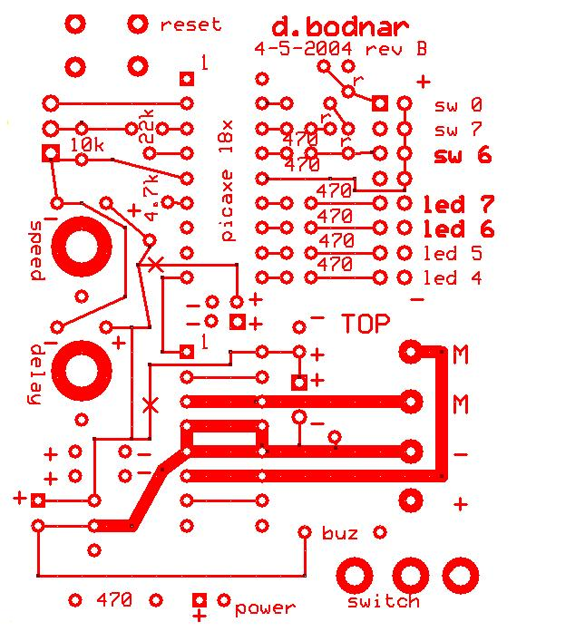
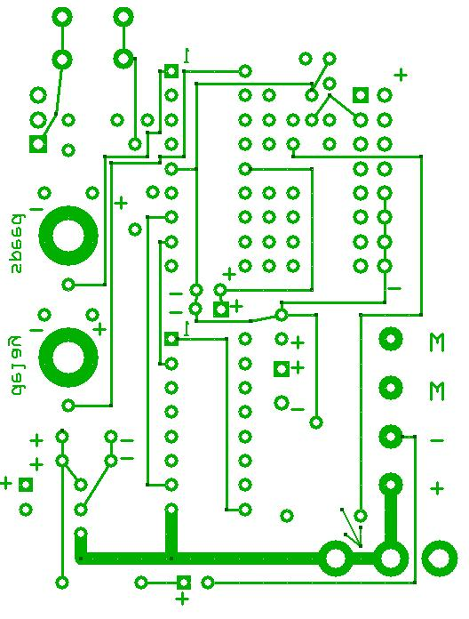
Construction
Note that the following assumes you are using the custom circuit board. If you are wiring your own by hand you should be able to place and wire components similarly.

First gather all of the parts that you will need and heat up your soldering iron. Make sure the tip of the iron is clean and “tinned” with a light coat of fresh solder. Check off each section of the construction list as you go. I have inserted a few test items as each section is completed as well as some test software. Make sure one section is tested successfully before moving on.

I also recommend that you use a magnifying glass or jeweler’s eyepiece to visually inspect each solder joint before applying power. Solder “bridges” between pads on the board are a common source of problems. It is also important not to get solder onto pads or other areas of the board before you insert components. If solder fills a hole before you insert a device it can be very difficult to get it in later on.

All of the component locations are not marked on the circuit board due to space issues. The photos and schematic should provide enough information for placement. If in doubt double & triple check! It is much easier to get it right the first time than it is to remove and relocate a component!

Construction Check List

- Insert the two sockets into the board. The sockets go on the side of the board marked TOP. Note that the small notch at one end of each socket indicates the end with pin 1. Be sure that each and every pin passes through to the back of the board before soldering. Once you start soldering the chip in it is very difficult to remove it should you find a pin bent under the socket!
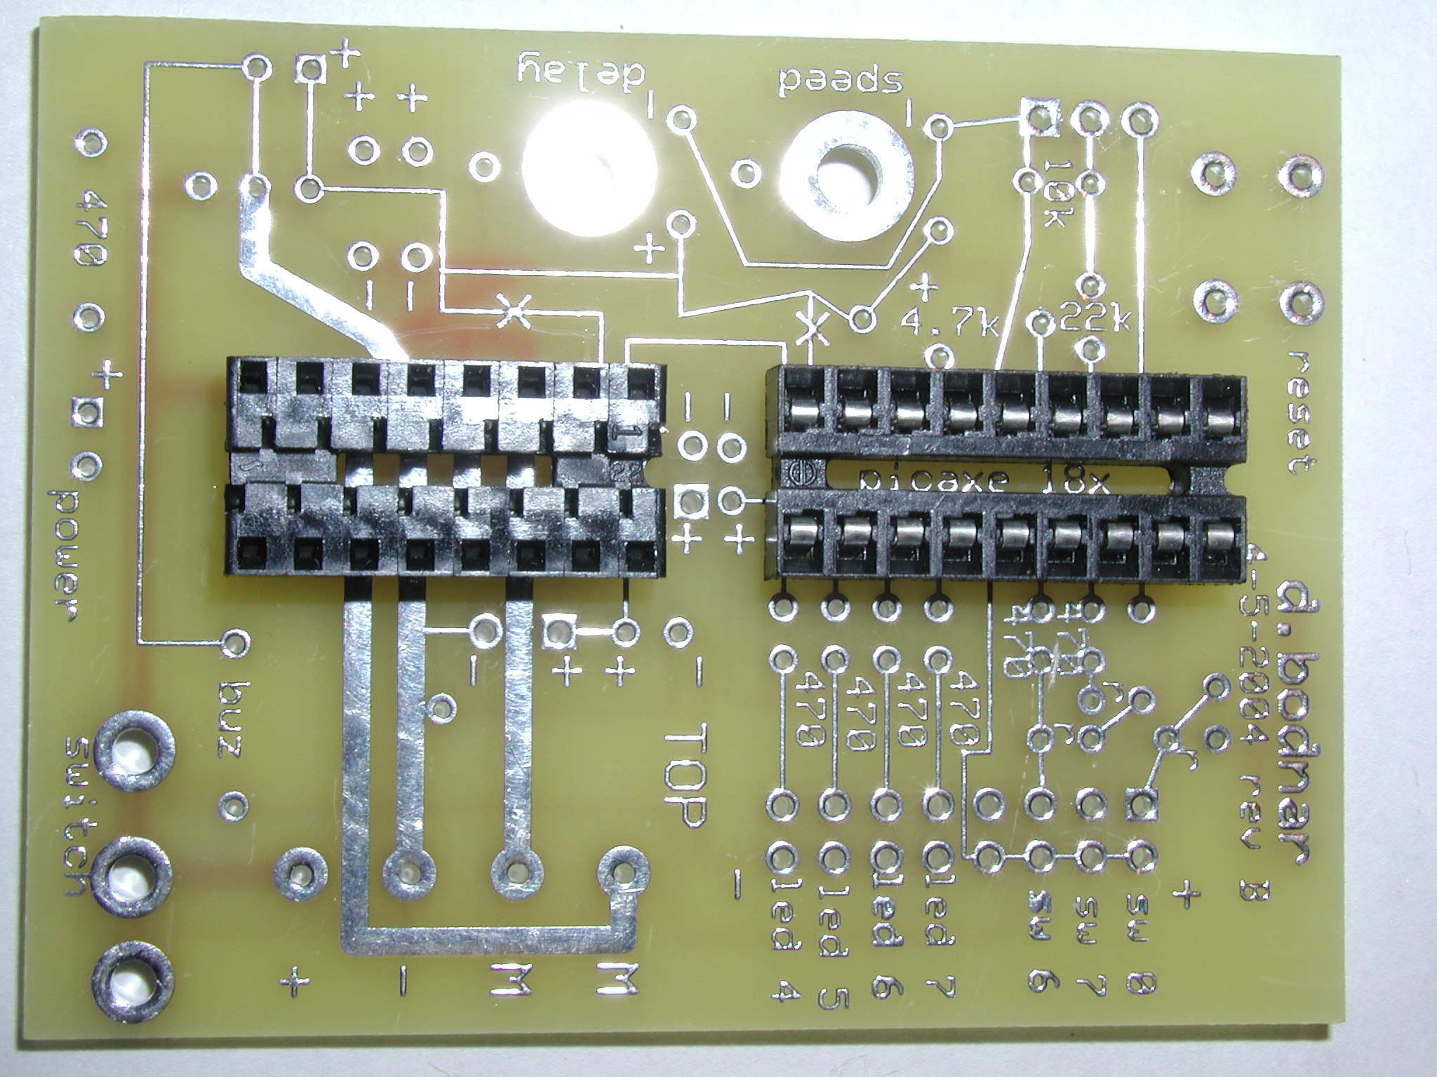
- Turn the board over and begin soldering the sockets. I usually solder just two pins on each socket (diagonal corners) then check to make sure the socket is flat against the board before continuing with the other leads. DO NOT insert the ICs into the sockets now.

- Insert the 78L05 into the board. See the photo for the placement of this device. The flat part of the device goes towards the edge of the board. Once it is soldered in cut off any wire extending from the back as close to the board as possible.
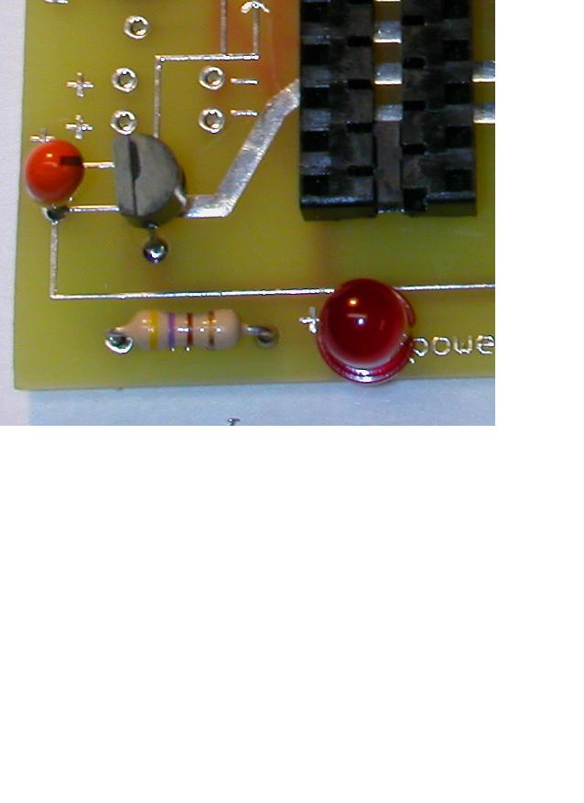
- Insert the 10 mfd capacitor in front of the 78L05. There is a small line on the capacitor that identifies the positive lead. The positive lead is also the longer of the two. On the caps I am using the labels goes towards the 78L05. The positive lead goes in the hole marked with a + sign. Solder and clip the leads

- Insert an LED and 470 ohm (yellow / violet / brown) resistor as in the photo. Bend the resistor leads carefully over a pencil tip to form them. The longer lead on the LED goes in the + hole. There is also a flat side to the LED that goes to the negative side. Place close to the board and solder. Note that resistors don’t care about polarity and can go in either way.

- If you are soldering power and motor leads directly to the board you can solder a red wire to the + solder pad to the right of the 16 pin socket (see photo) and a black wire to the – solder pad. The motor leads will go to the pads marked with “M”’s. If you are using the 4 position terminal block solder it in now. Note that the ones I have been using can be a tight fit but the pins should go through the holes!
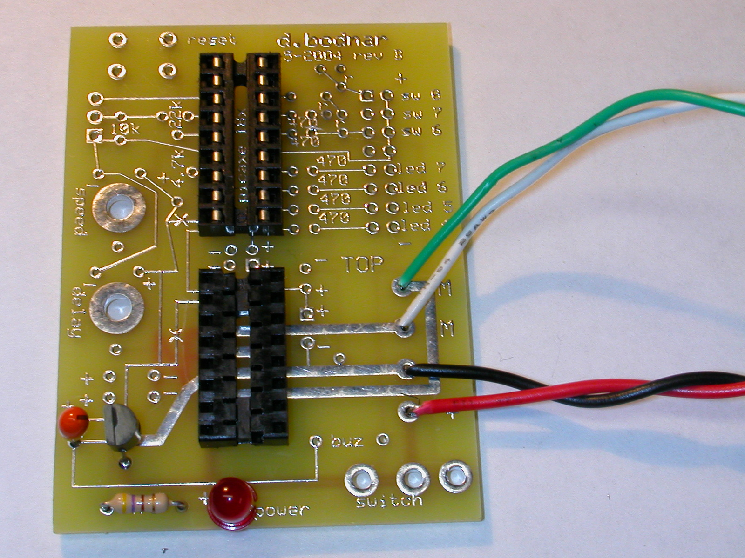
- Briefly connect a 9 volt battery to the + and – terminals. If the LED does not light remove power immediately and recheck your connections. If it does light use your meter to test for + 5 volts between pins 5 and 14 on the 18 pin socket. Just put the black test lead on pin 5 and the red lead on pin 14. The meter should show 5 volts. You can also test for 5 volts between pin 4 and pin 16 of the 16 pin socket (black on pin 4, red on pin 16)

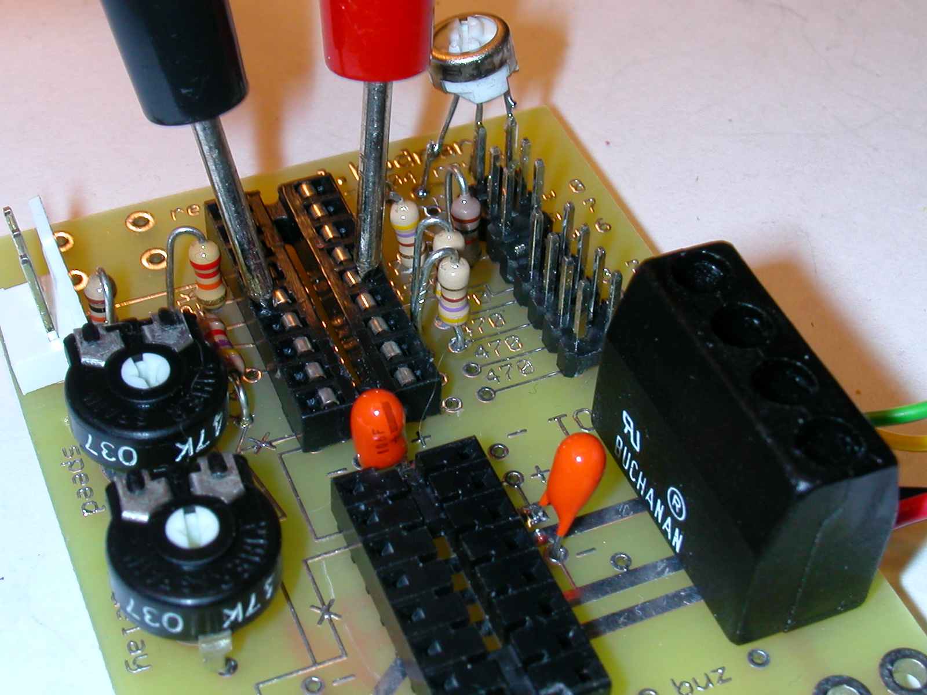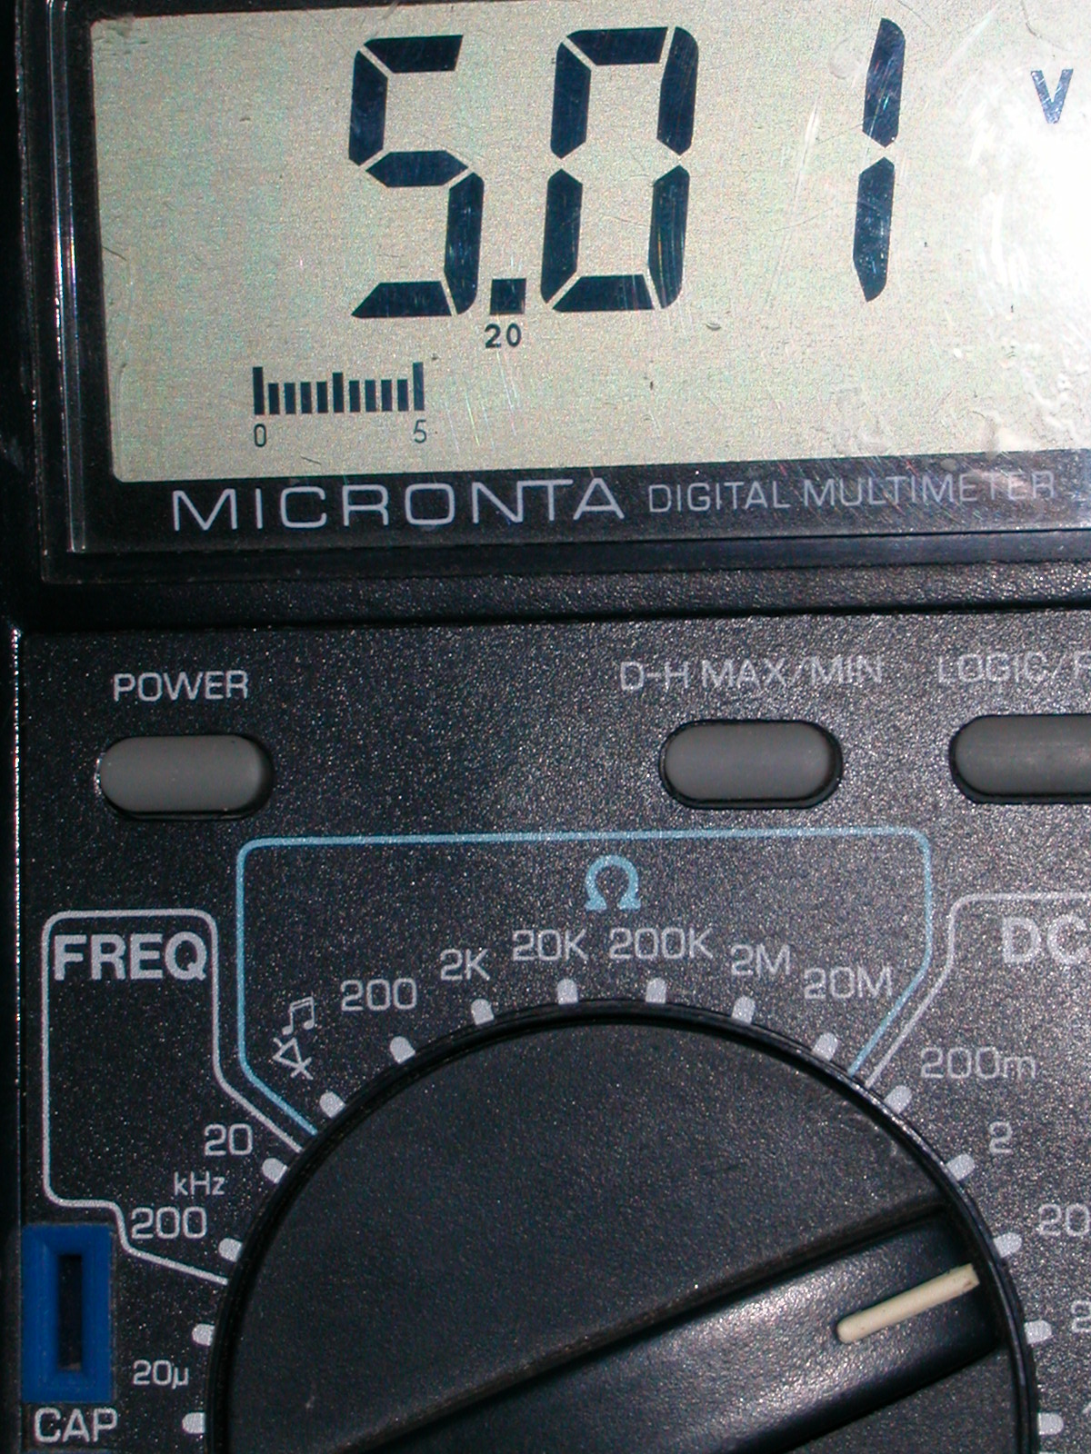
- Locate the 22K (red / red / orange), 10K (black / brown / orange) and 4.7K (yellow / violet / red) resistors. Each of these components go to the left of the 18 pin socket. Their locations are marked on the board. The 10K and 22K resistors must stand up on the board. Bend the leads as in the photo before inserting in the board. Solder and clip the leads.
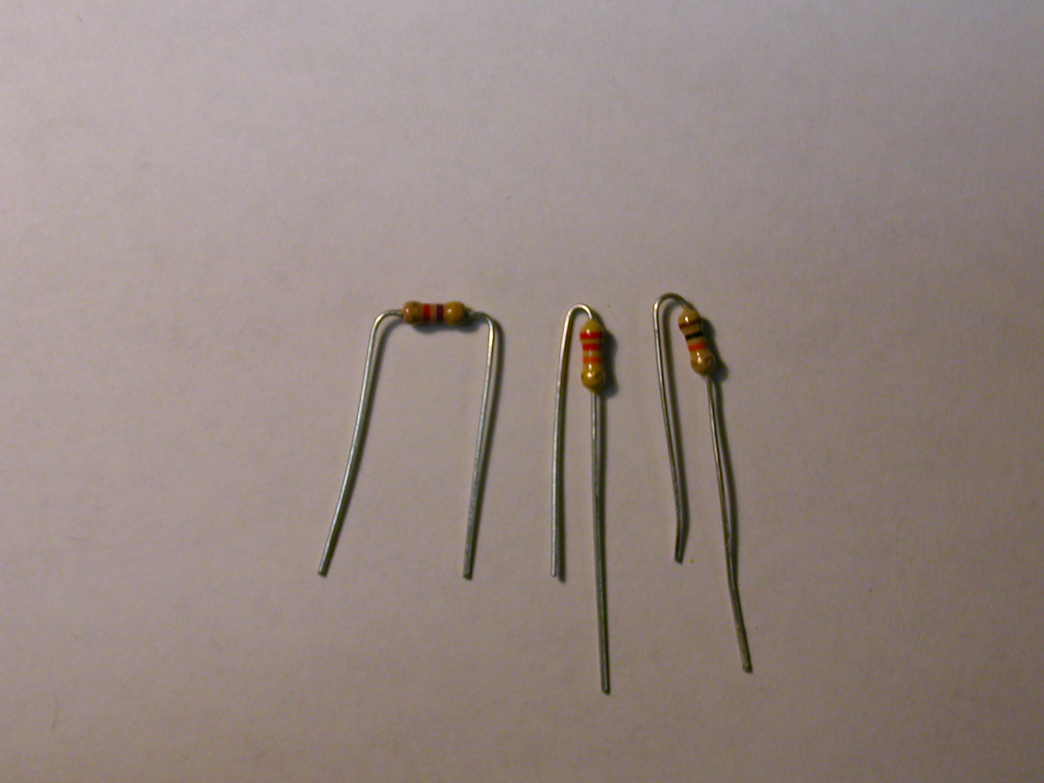
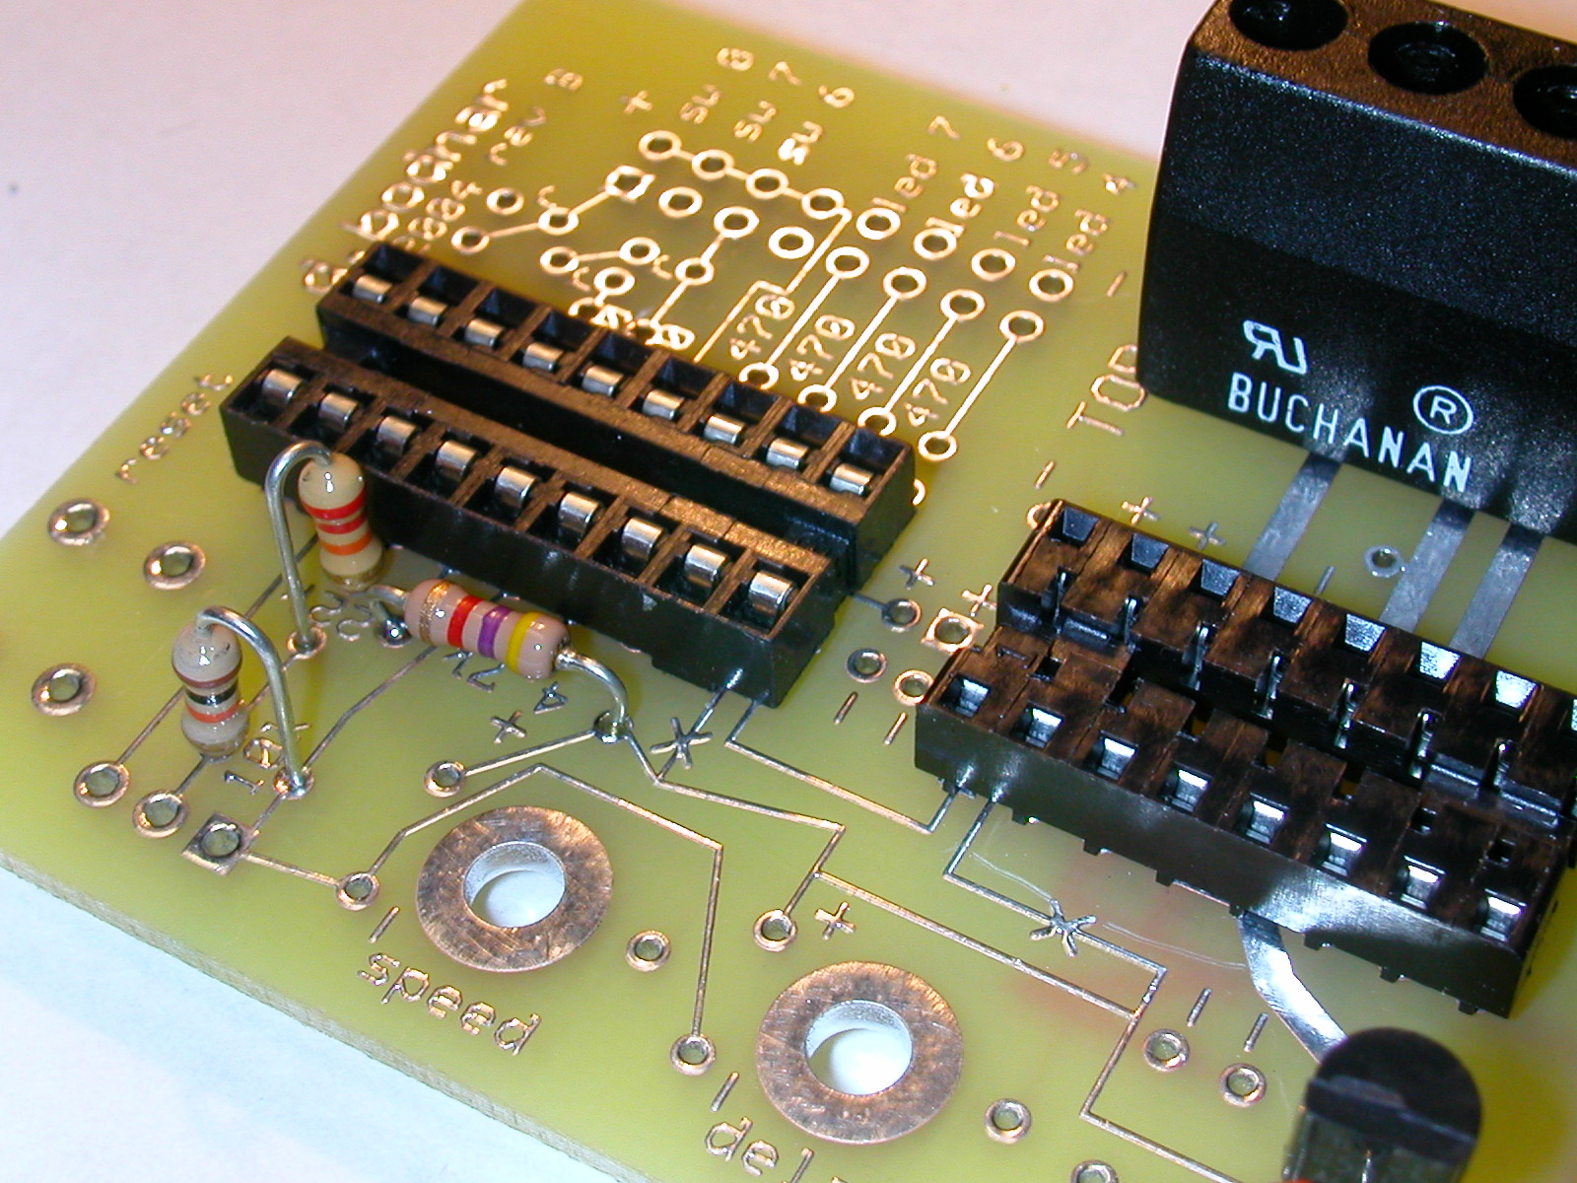

- Insert the 3 pin header into the holes next to the 10K resistor you just placed. This is the connection that will go to the PC for programming. Solder in place.
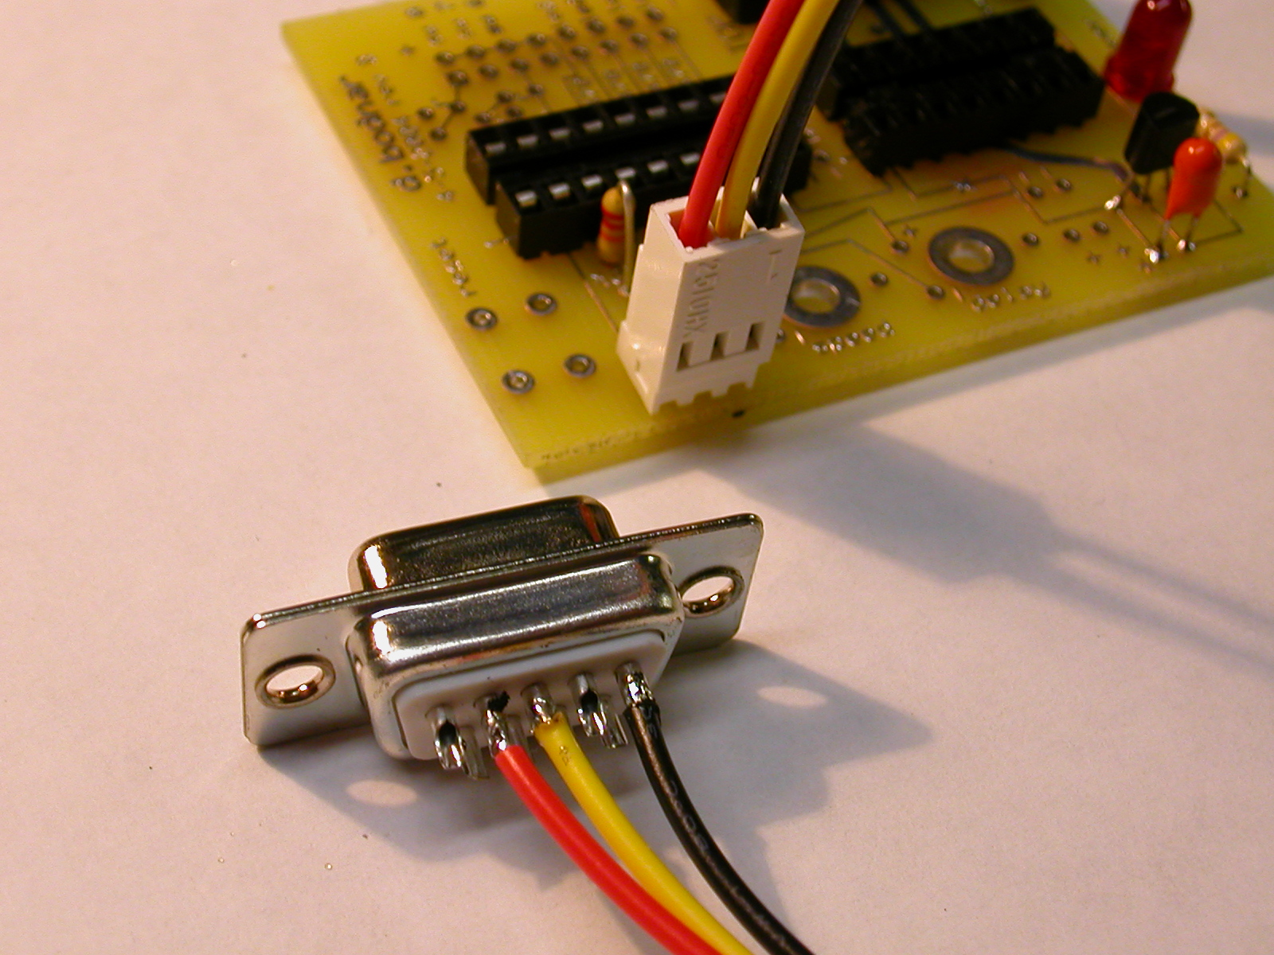
- Solder the three wires from the 3 pin plug to the DB-9. On the cable I made the black wire goes to pin 5, the yellow wire to pin 3, and the red wire to pin 2. If you are using your own materials consult the schematic. The important thing is that Pin 5 on the DB-9 goes to the right connector pin that goes to pin 5 on the Picaxe, DB-9 pin 3 goes through the 22K resistor to Pin 3 on the Picaxe and DB-9 pin 2 goes to Picaxe Pin 2. Make sure that you always insert the cable so that the ground wire (black wire that goes to pin 5 on the DB-9) goes towards the potentiometers. In the photo it would be towards the right.

- If you haven’t already downloaded and installed the software from the Picaxe site do it now as we will be testing the microprocessor in the next step.

- Connect the 9 volt battery again and double check that you have 5 volts between pins 5 and 14 on the 18 pin socket. We will be inserting the Picaxe microprocessor and don’t want to “smoke” it!

- Remove power from the circuit and insert the 18 pin Picaxe. Note that pin 1 is at the end of the chip that has a crescent shaped notch in it. It is also identified with a small dimple in the top of the chip. It is sometimes necessary to form the pins before inserting the chip in the socket. If necessary, gently bend them to better fit the socket. Be careful when inserting the chip as it is easy to bend one or more pins if you force it.
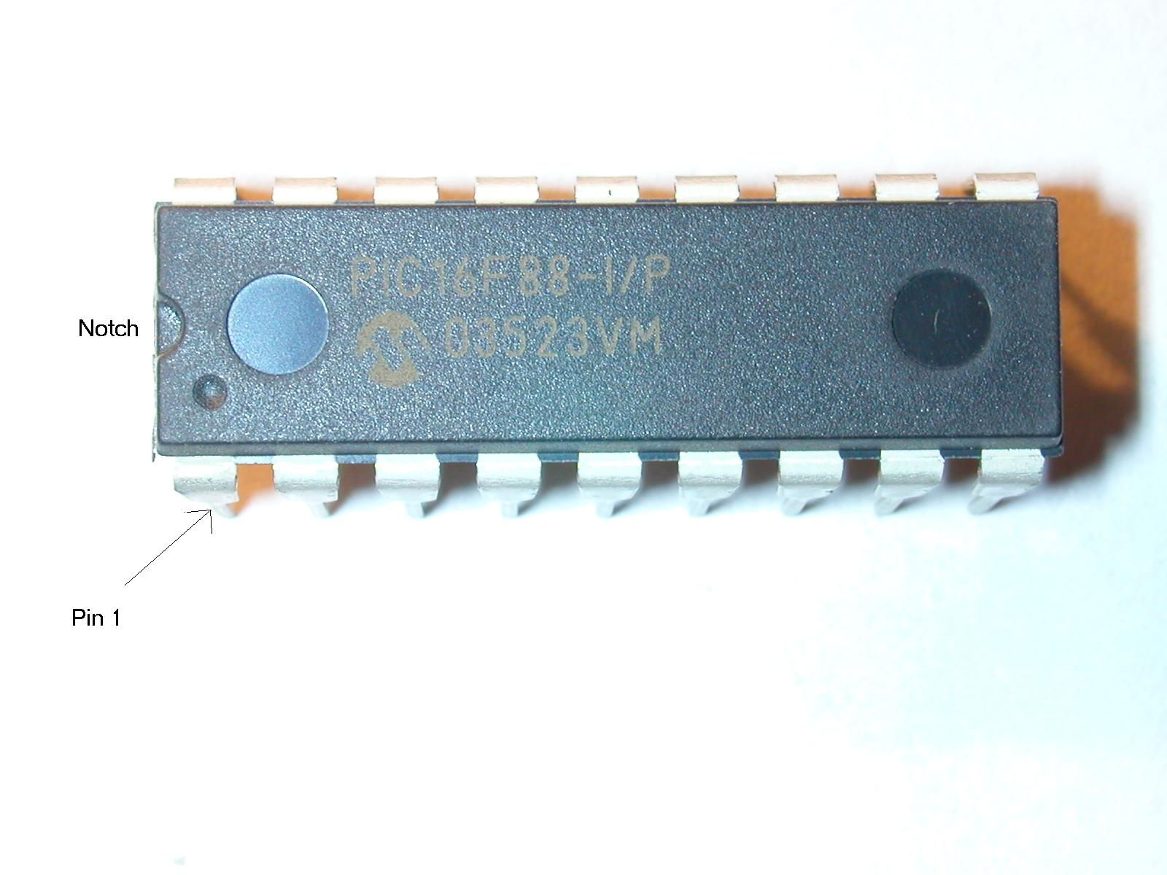
- Briefly restore power to the circuit. Make sure the LED lights before continuing. If it does not remove the Picaxe and check your wiring.

- Connect the DB-9 to the serial port on your PC. Connect the other end to the circuit board. Make sure the black wire goes to the right as you look at the side of the board.

- Run the Picaxe Programming Editor. You will be asked what mode you are using. Select 18x. Click on COM and select the com port you are using. If these questions do not come up automatically just click on View and Options.

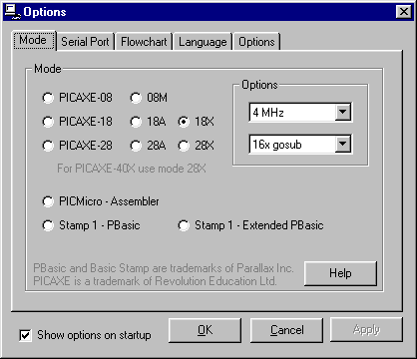

- Type this simple program into the editor:

start:
for b1 = 0 to 255
debug b1
next b1
goto start:

Press the F4 function key to check your syntax. Correct any errors in the program.
Press the F5 function key to download the program to the Picaxe.
You should see a download screen and a progress indicator as the program loads. Once it is done a Debug windows will come up and show the value of B1 (a variable in the Picaxe) changing from 0 to 255 over and over.

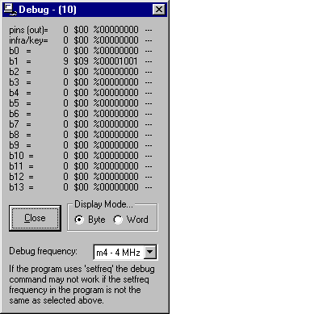
- If the program does not download to the Picaxe make sure your com port is not being used by another program (a palm pilot, for example, will frequently hang onto a com port even when disconnected) Also check wiring and examine the circuit board to make sure there are no solder bridges between pads. Also check that the programming cable is plugged into the board correctly.

- Locate three 470 ohm (yellow / violet / brown) and one 10K (black / brown / orange) resistors. Shape the leads so that all can be inserted standing up. See the photo for placement. Each of these components is inserted to the right of the Picaxe (next to pins 10-18 on the Picaxe). There are holes for many more resistors than we are using. These may be added later on when more sophisticated things are done with the system. Be careful that you put the components in the right holes! Note that the 470 ohm resistors all go next to the Picaxe and that the 10K resistor is placed to the side of the 470 that goes to pin 15 on the Picaxe.
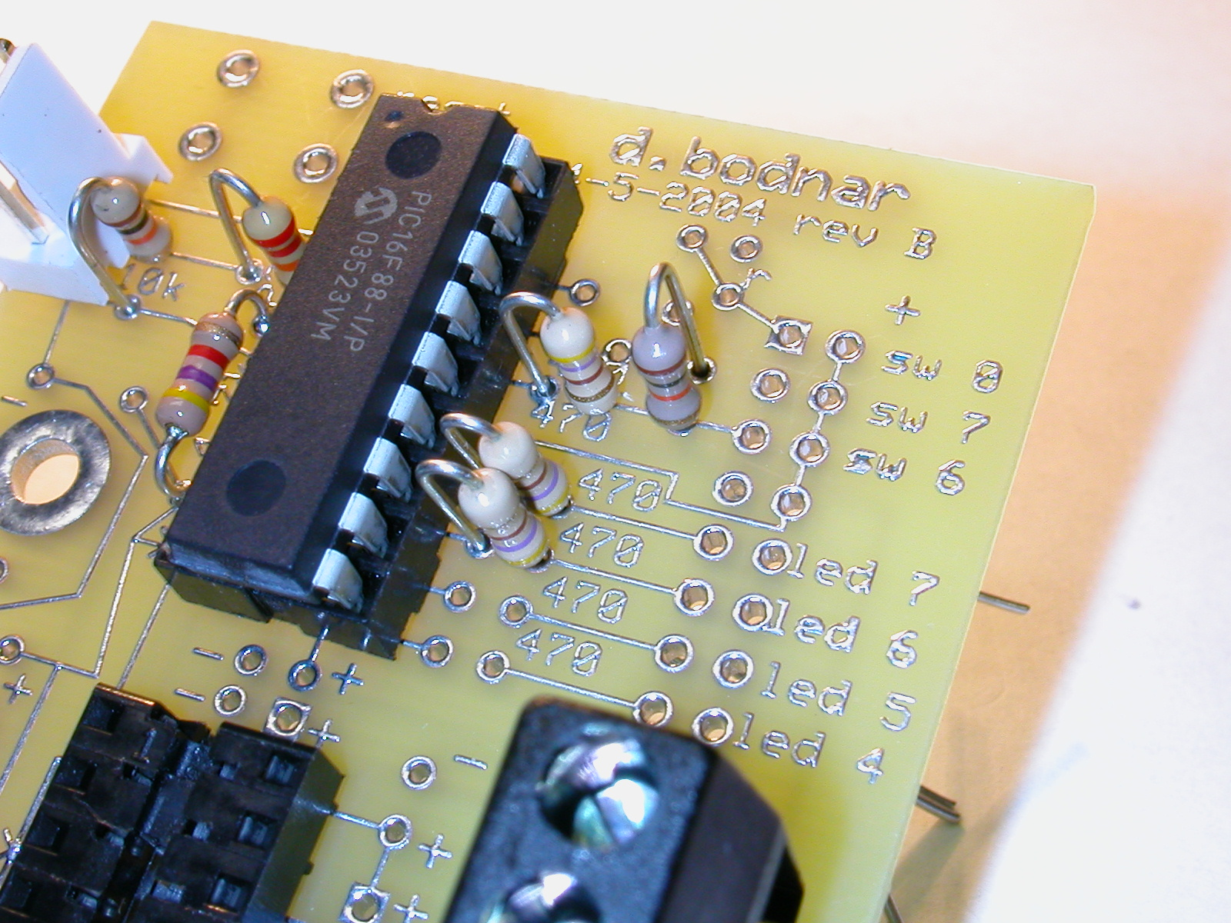

- If you are planning on soldering LEDs and the reed switch directly to the board you can skip this step. The header I am using is 2 pins wide x 8 pins long. I removed two pins that are not used so that the header has 2 x 3 pins, a space and 2 x 4 pins. The 3 pin section goes next to the pins marked sw 6, 7 and 8. The 4 pin section next to led 7, 6, 5 and 4. Place and solder the header.

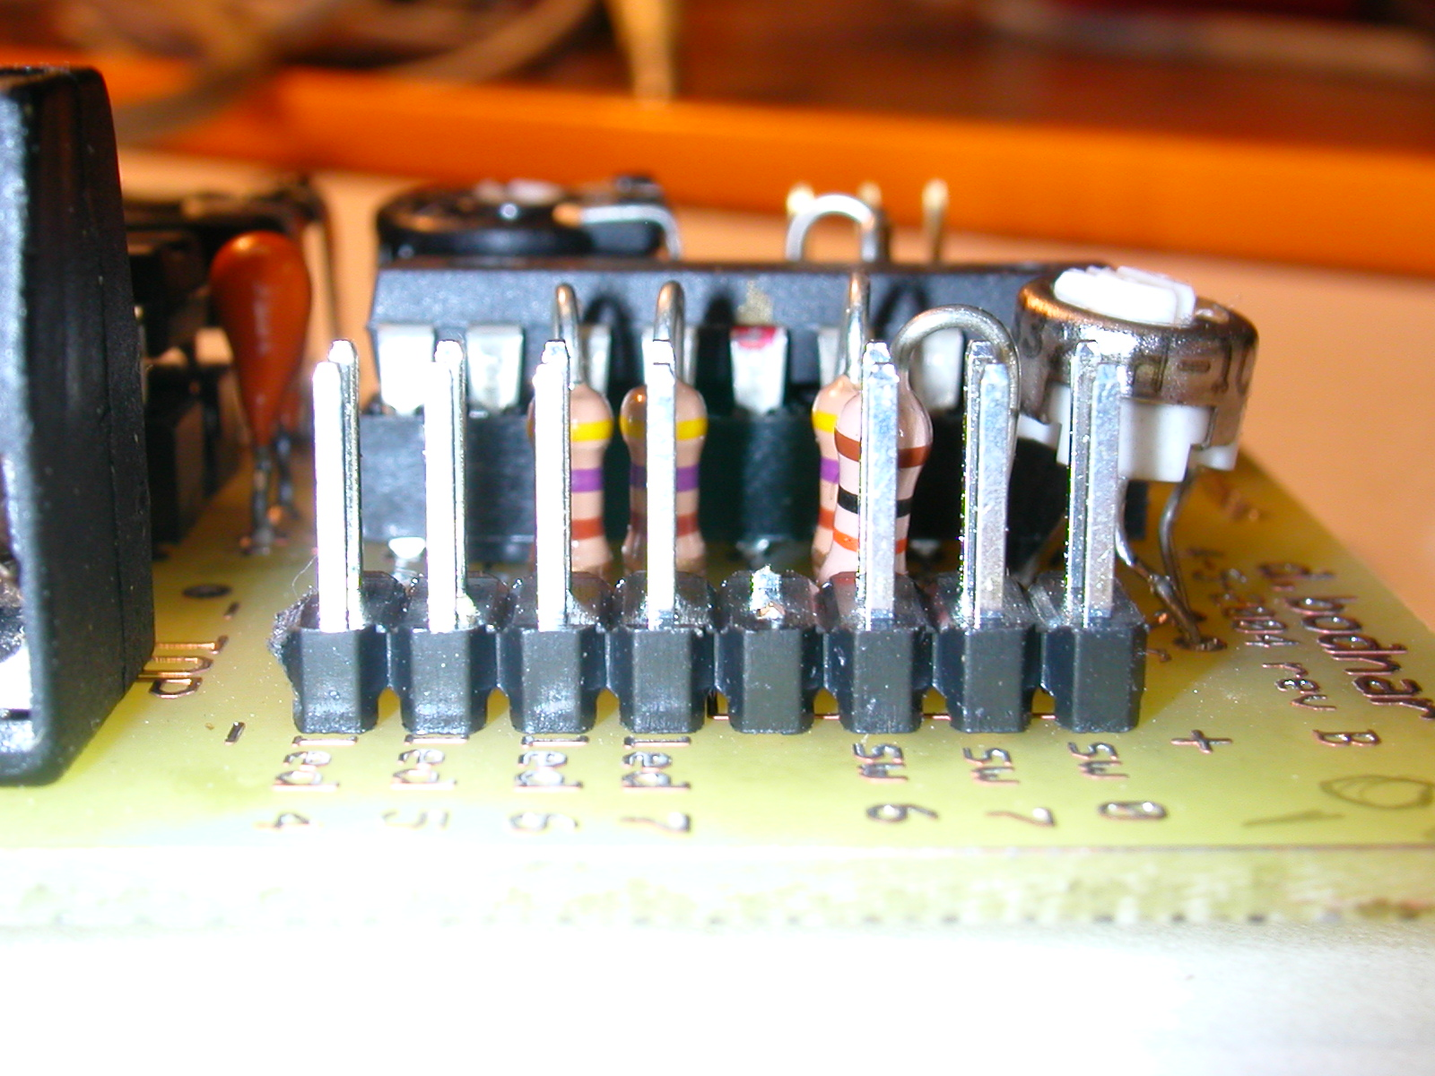
- Place the last two 10 mfd capacitors as in the photos. Remember that the longer lead (the one identified with a line on the cap) goes into the + hole and the other in the – hole. Solder and clip off the leads.

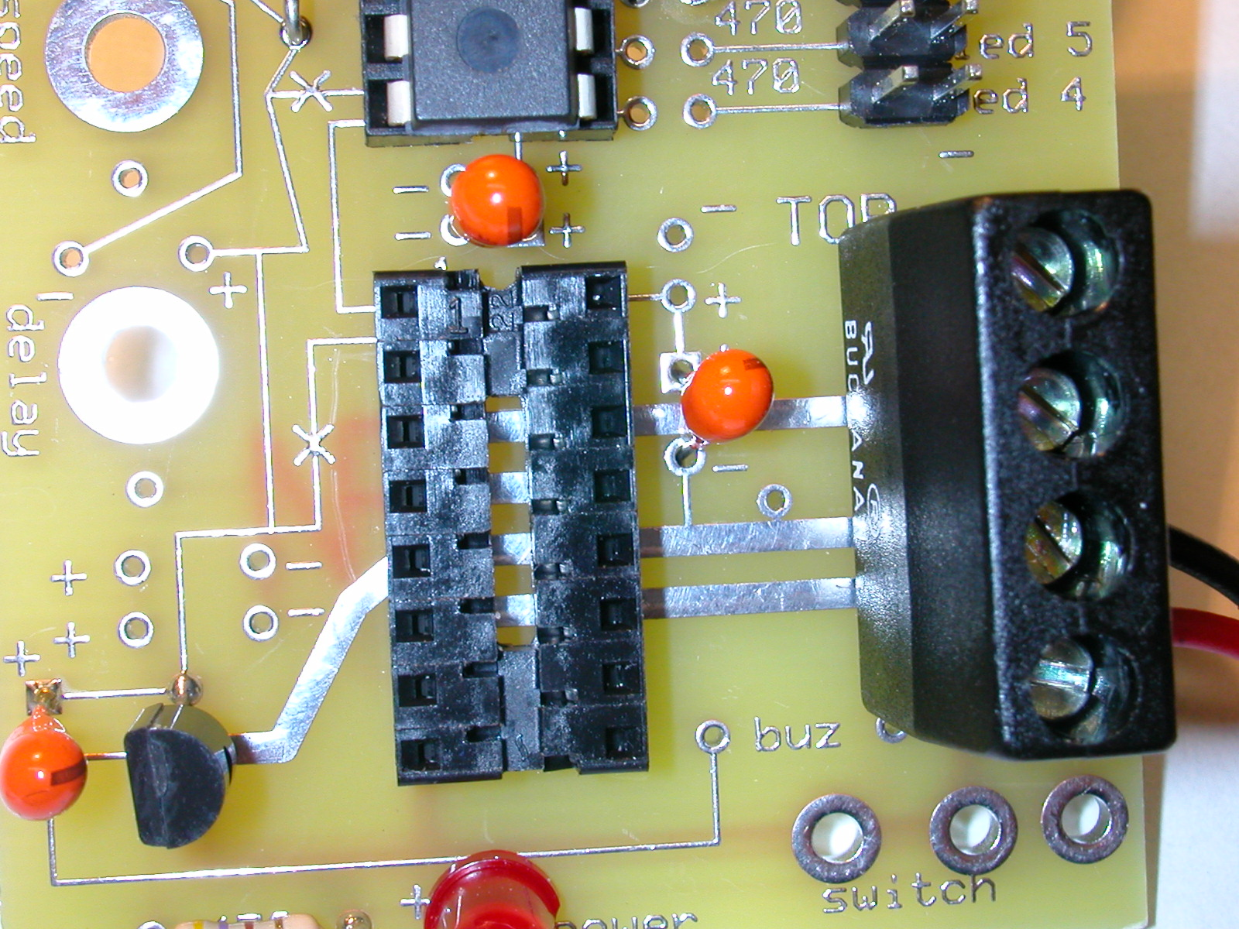

- Connect two LEDs to the header next to “led 7” and “led 6” – the longer (+) lead on the LED goes to the part of the header closest to the Picaxe and the shorter (- end with a notch on the LED) goes to the part on the edge of the board. Solder wire to each end of the reed switch and connect it to the two pins next to “sw 6” on the header.

- Apply power and type the following program into a new editor window to test the LEDs and reed switch:

‘led test program
start:
high 7:low 6
if pin6 =1 then reed:
pause 300
low 7:high 6
if pin6 =1 then reed:
pause 300
goto start:

reed:
high 6
high 7
pause 5000
goto start:

The two LEDs should blink on / off. When a magnet comes close to the reed switch both LEDs should stay on for 5 seconds.

- We now need to make a decision about where to locate the potentiometers. They can either go on the board or somewhere external to the board (under the engine, for example).
  - On board pots - the two 47K pots go over the two large holes between the 78L05 and the PC connector – the leads for the pots are too large to go through the holes but fit nicely over them. Bend the leads slightly (see photo) and tin the ends with a bit of solder. Place the pots over the pins on the board an apply heat with the iron. Repeat with the 2nd pot. Note that the pots I used can be adjusted from both sides of the pot. That is why there is a large hole under each pot. It gives you the capability of adjusting the pot from a strategically placed pair of holes under the board.
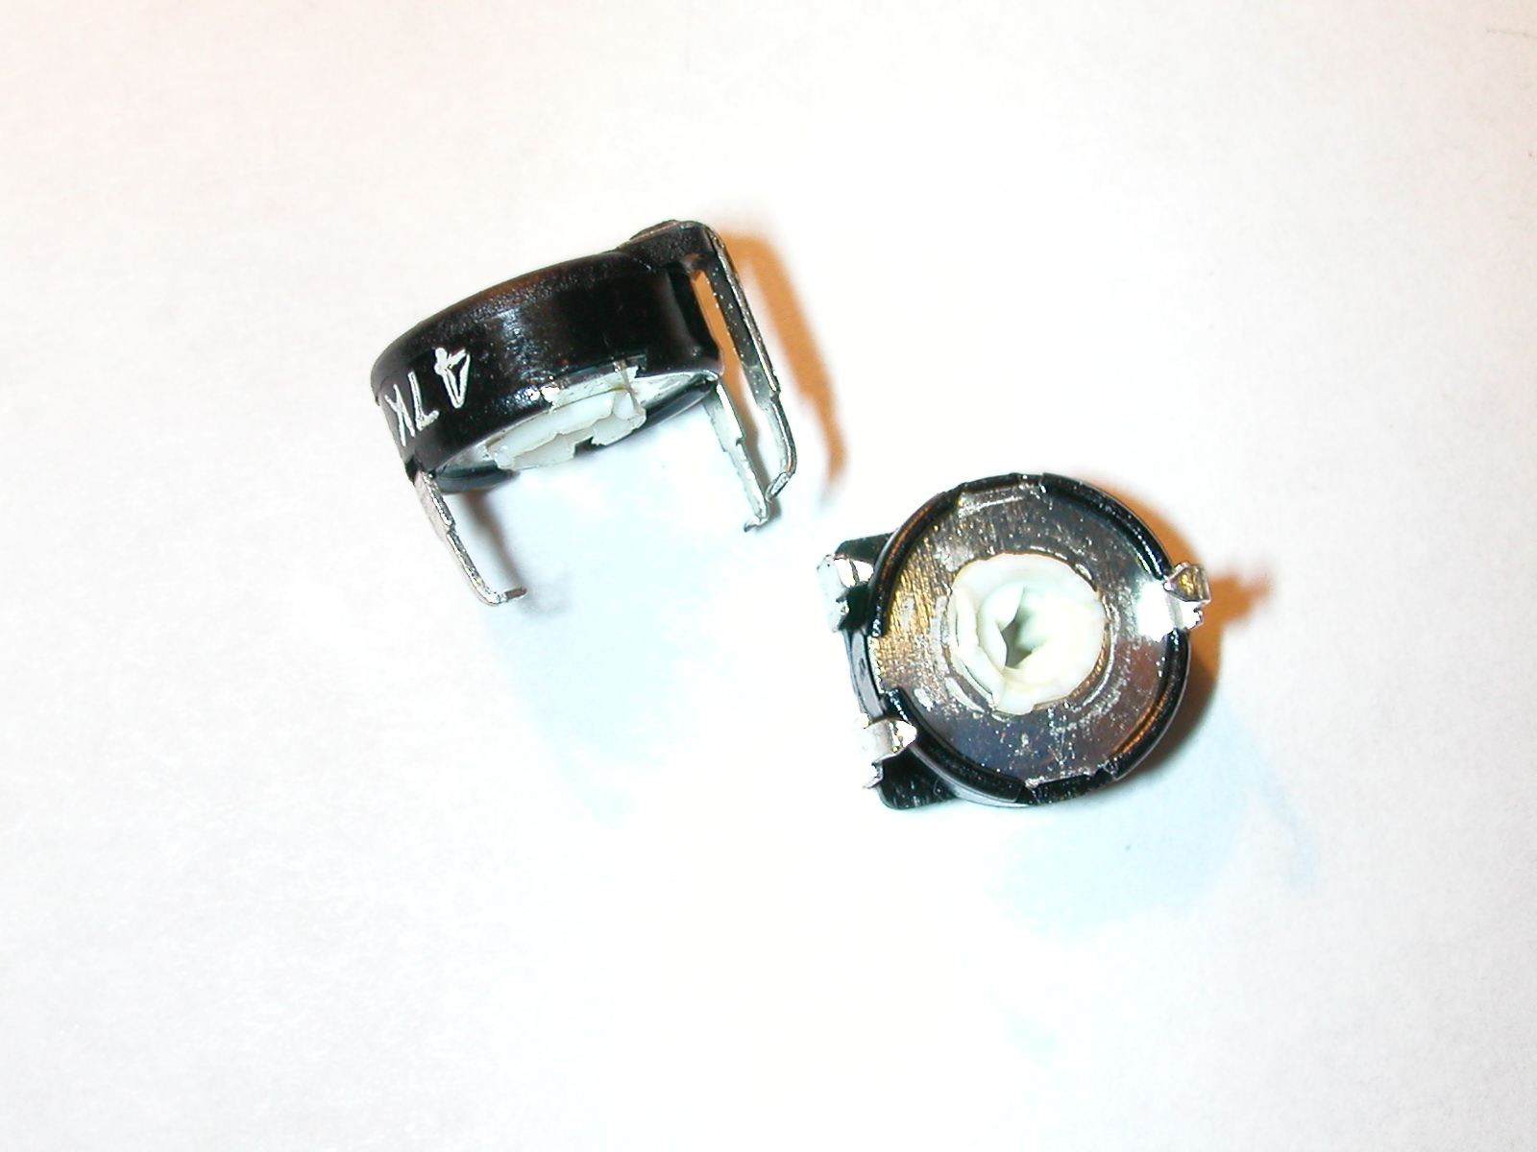
  - Off board pots – some or all of the pots can be placed off the board. If you want to place them elsewhere all you need to do is run 4 wires (one for +5 volts, one for ground and one each for the connections to pins 1 and 18 on the Picaxe.) Wire one end of the fixed part of each pot to + 5 the other end of the fixed part to ground. Run the center (wiper) lead to the board. The lead for “speed” goes to the pad above and a bit to the right of the “d” in the word “speed” and the lead for delay goes to the pad above and to the right of the “y” in “delay” 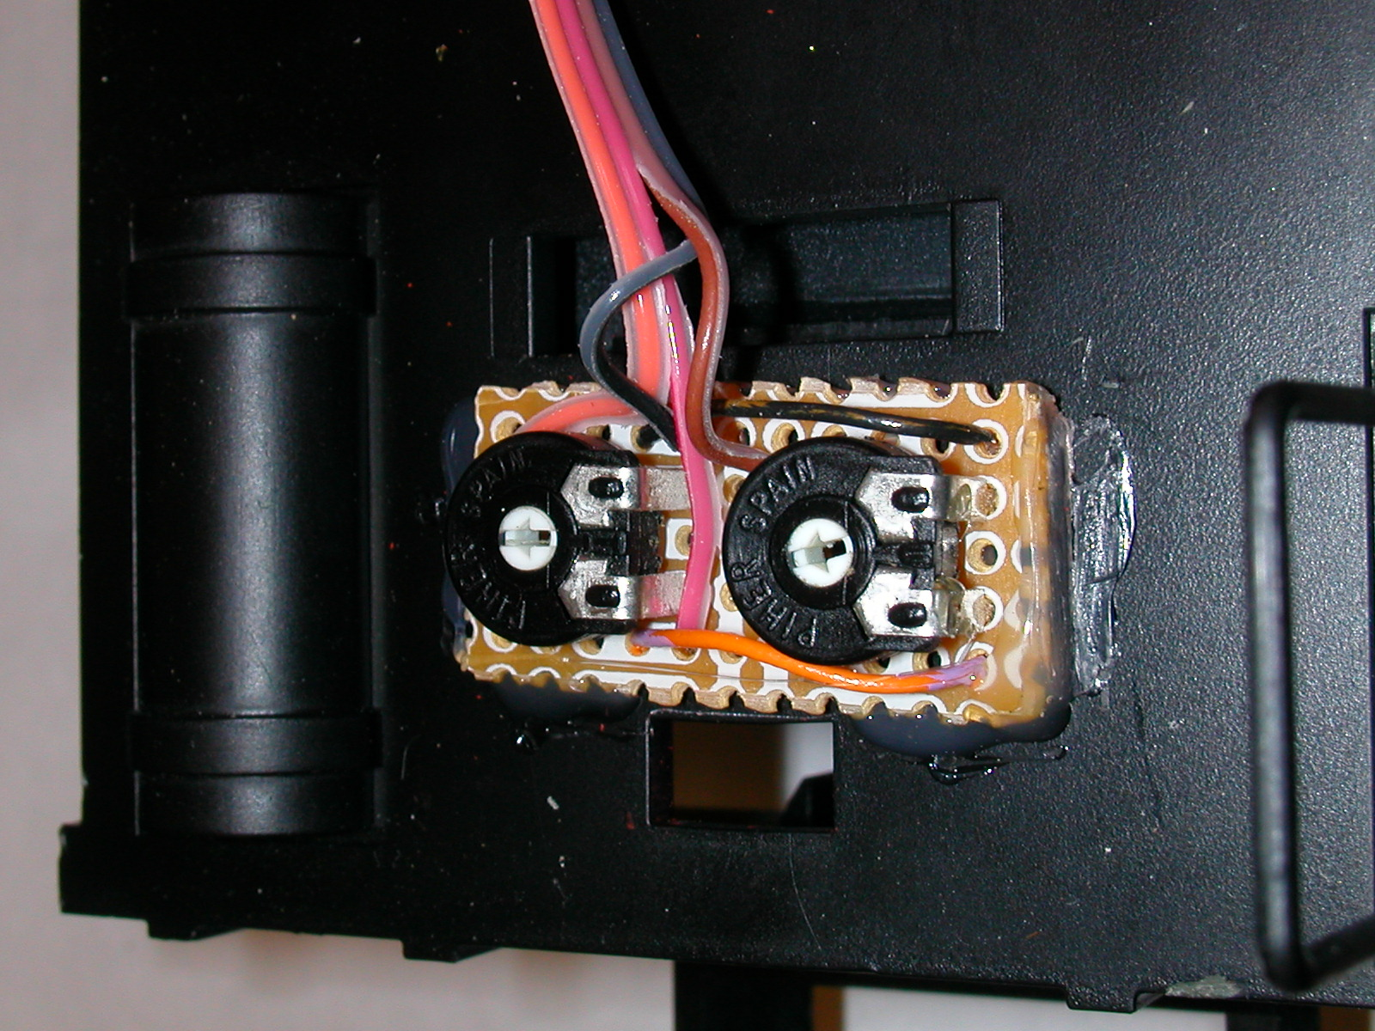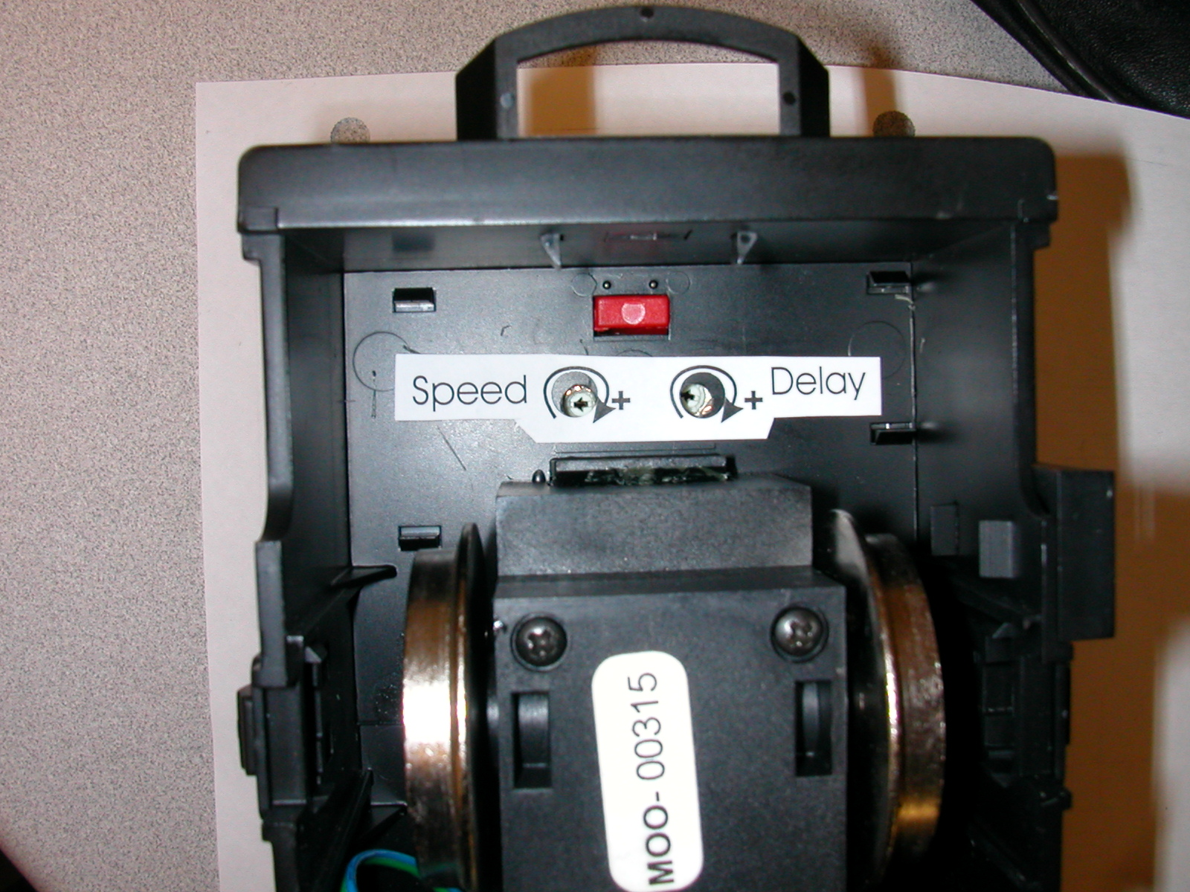
- Open a new editor window and type the following program into the Program Editor (or cut / paste it in) to test the three pots. When run you should be able to change the value of B1 and B2 between 0 and 255 by adjusting the pots with a small screwdriver
‘pot test program
start:
readadc 0, b1
readadc 1, b2
debug b1, b2
goto start:

If any of the variables do not change make sure that the potentiometer associated with that variable is properly connected to +5 volts on one side and ground on the other. For example, if B2 stays at 255 it is likely that one end of the pot that goes to Picaxe pin 1 is properly connected to +5 volts but the other is not connected (or has a bad solder joint) to ground.

- Make sure power has been disconnected and put the “H-bridge” chip in the 16 pin socket. Remember that the notch is next to pin 1. This chip does NOT have a dimple next to pin 1. Note that both the Picaxe and “H-bridge” face in the same direction.

- Apply power and confirm that the LED lights as before. Disconnect the power and connect a small DC hobby motor to the two pads labeled “M”. Since we are still working with a 9 volt battery there will not be sufficient power to turn a large engine’s motor. The advantage of doing things this way is to protect the chips from being damaged should the wiring be incorrect. A 9 volt battery can’t deliver any where near the current of a set of NiMH or NiCad cells.

- Type or cut & paste the following program into a new editor window to test the motor.

‘motor test program
high 1
low 2
start:
for w1= 200 to 1000 step 40
pwmout 3, 249, w1
pause 400
next w1
pause 5000

for w1= 1000 to 200 step -40
pwmout 3, 249, w1
pause 400
next w1
pause 5000
toggle 1
toggle 2
goto start:

The motor should start slowly, speed up, run for a few seconds, slow, stop, reverse and repeat. If you note a tone coming from the motor that is due to the PWM pulses being used to activate the “H-bridge”

- That’s it for construction – congratulations!

Software – how it works
testLED.bas
- The first line is a comment (starts with an apostrophe)
- The second line is a label “start:”that is used as an address that the program can return to when needed.
- “high 7 and low 6”turn the LED on output pin 7 on and the one on output pin 6 off
- “if pin6 = 1 then reed:”does a test – if input pin6, which goes to the reed switch, is connected to 5 volts then it jumps to the label “reed”
- “pause 300”waits for 300/1000 seconds
- The next three lines switch the LEDS that are lit, check for the button being pushed and pause again.
- “goto start:”starts over
- “reed:”is another label – the program goes here when the switch is on. The lines that follow turn both LEDs on, pause for 5 seconds and return to “start:”
testMOTOR.bas
- The first two program lines, high 1 and low 2, set the LM293D motor control chip to turn in one direction. If both were high or both low the motor would not run
- After the “start:”label is a for/next loop. It tells the computer to count from 200 to 1000 by 40’s and to store the current number in a storage place, or variable, called W1
- The magic happens in the next line, “pwmout 3, 249, w1”- this line tells the computer to send a variable voltage to the enable pin on the LM293D. You may recall that the enable pin on this device turns it on and off. It interprets 5 volts as on and 0 volts as off. The pwmout command sends a series of pulses that can simulate voltages between 0 and 5 volts. The higher the voltage it sends with this command the faster the motor spins.
- After the pulse is sent the program pauses for 400/1000 seconds
- “next w1”tells the program to continue counting with the for/next command.
- Once the computer counts up to 1000 it pauses for 5 seconds and counts back down with the “for w1 = 1000 to 200 step -40”command.
- After another 5 second pause the direction pins are toggled, that is the one that is on goes off and the one off goes on and the program continues
testPOT.bas
- This simple program uses the command “readadc”to read a voltage between 0 and 5 volts on a pin and report that voltage as a number between 0 and 255.
- “readadc 1, b0”reads the voltage on pin 1 and places the result in the variable b0 – the second readads reads pin 2 into b1
- “debug b0, b1”has the program report the value of the variables to a box on the programming screen . This is an easy way to see what is happening with a program.

Auto reverse software
The objectives of this program are
- Train accelerates smoothly to some preset speed
- Speed is maintained until the train crosses a magnet on the track
- The programs uses interrupts to assure sensing a magnet even at high speed
- Train decelerates smoothly and stops for a predetermined time
- Train reverses, accelerates and continues on its way until another magnet is encountered where it reverses again

Since this is the main program that is used for the engine controller it is much more detailed containing comments on most lines and using word labels to represent variables. This makes the program much more understandable. The “symbol”command that is used more than a dozen times at the top of the program substitutes a word for a pin or variable. Besides making a program more understandable, it also allows you to easily modify a number that occurs at a number of places in a program by simply changing its value in the symbol area.
The rather cryptic command “setint i_rupt, i_rupt” sets up a very powerful capability of the program called an interrupt. The interrupt forces the microprocessor to continually look at one or more of the input pins and to immediately react if the condition that is being looked for is met. The command “setint i_rput, i_rupt” (i_rupt =%01000000) tells the computer to look at input pin 6 and to go to the interrupt part of the program if that pin becomes high. This happens when the reed switch is closed by a magnet on the track.
The section of the program after the label “interrupt” is executed whenever the engine passes over a magnet.
The other special feature of the program is the variable “magnetFlag” that has the microprocessor skip over the magnet that told it to reverse. If this is not used the engine will go back and forth over the same magnet over and over again! This was discovered the first time I ran the prototype on a track with a magnet. The engine passed the magnet, slowed, paused and reversed and promptly repeated the sequence as soon as it passed over the magnet again! I had a wonderful oscillating railroad engine! Cute, but not of much use until the “magnetFlag” was added.

'd. bodnar 4-13-04 - 18x chip rev 9a
' third pot added
'speeds up motor and slows / reverses on reed switch
'magnetFlag (bit0) is flag to skip 2nd pass over same magnet on reverse
symbol ver = 9 'version to flash at start
'symbol howlong = 100 'delay in accelerate / decelerate loops
symbol HBridgeD1 = 1 'output - H-Bridge chip direction pin
symbol HBridgeD2 = 2 'output - other H-Bridge chip direction pin
symbol pulse = 3 'output - H-Bridge pin for pwm
symbol LED = 6 'output - LED on pin 6
symbol LED2 = 7 'output - LED on pin 7
symbol magnetFlag = bit0 'used to skip over first magnet on reverse
symbol doitflag = bit3 'set if ready to reverse
symbol tone = b1
symbol flashLED = b2 'variable for for/next flash
symbol stoptime = b3 ' long to pause
symbol toppot = b4 'read pot for top speed
symbol stoppot = b5 'read pot for pause time
symbol accloop = w3 'variable for accelerate for/next
symbol top = w4 'top of accelerate for/next
symbol period = 124 'constant for PWM period
symbol lowend = 300 'constant for small end of for/next loop
symbol stp = 4 'constant for step in for/next loop
symbol i_rupt = %01000000 'binary for pin 6 interrupt
symbol temp = b10 'temporary variable
symbol accpot = b11 'read pot for acceleration /decel rate
'the next three lines flash major version number on LEDs at startup
high LED:low LED2
for temp=1 to ver:toggle led:toggle led2:pause 200:toggle led:toggle led2:pause 200:next temp
pause 1000

setint i_rupt, i_rupt 'Use interrupts to check for pin 6 being high
high HBridgeD1:low HBridgeD2:magnetFlag=0 'initialize, forward -clear skip magnet flag

speedup:
gosub get_toppot: 'read setting from top speed potentiometer
for accloop=lowend to top step stp 'accelerate loop start
pwmout pulse,period, accloop 'send pwm pulses
toggle led:toggle led2: 'blink LEDs
pause accpot 'pause sets acceleration rate
toggle led:toggle led2: 'blink LEDs
pause accpot 'pause sets acceleration rate
if doitflag=1 then slow_reverse: 'doitflag set by interrupt detecting magnet
next accloop 'back to start of for/next loop

maintain_speed: 'keep steady speed routine
high led 'LED on
gosub get_toppot: 'read setting from top speed potentiometer
pwmout pulse,period, top 'send pwm pulses
low led 'LED off
if doitflag=1 then slow_reverse: 'doitflag set by interrupt detecting magnet
pause 50 'brief pause
goto maintain_speed: 'go to start of maintain_speed loop until interrupt

slow_reverse: 'decelerate reverse routine
high LED:low LED2 'toggle LEDs
gosub get_toppot: 'read setting from top speed potentiometer
for accloop=top to lowend step -stp 'decelerate loop start
high LED2 'turn off LED
pwmout pulse,period,accloop 'send pwm pulse
toggle led:toggle led2: 'provides a pre-scale of 1:4 use $06 for 1:16
pause accpot 'pause
low LED2 'turn on LED
next accloop 'back to start of acceleration loop
toggle HBridgeD1:toggle HBridgeD2 'reverse direction
magnetFlag=1:high LED 'set magnet flag & light LED
pwmout pulse, period,0 'send pwm for stop!
readadc 1,stoptime 'get pot reading for stop time
for flashLED=1 to stoptime 'pause flashing LED routine
high LED 'light LED
temp=stoptime-flashLED 'use temp variable for computation for next step
pause temp 'wait
low LED 'off LED
pause flashLED 'wait
next flashLED 'back to start of flash for/next loop
doitflag=0 'reinitialize flag
goto speedup: 'start over again!

interrupt: 'jumps here if magnet detected
if magnetFlag=0 then doit: 'if no flag do decelerate & reverse
if magnetFlag=1 then makemagnetFlag_0: 'if flag was set reset it (hit magnet on way back)
doit: 'label of place to jump to
doitflag=1:low LED2 'set flag to reverse
goto back1: 'skip over next part
makemagnetFlag_0: 'clear flag routine
high LED2:low LED 'light LED
magnetFlag=0 'clear flag
pause 800 'wait 8/10 sec to make sure we don't detect same magnet again
doitflag=0 'clear flag
back1: 'label of place to jump to
setint i_rupt, i_rupt 'reset interrupt for next magnet detection
return 'back to where we were when magnet detected

get_toppot: 'start of read pot subroutine
readadc 2,toppot 'get pot value
top=toppot * 4 'scale to max of 1023
readadc 0, accpot 'get accelerate / decelerate pot
return 'return to place were gosub was called and continue

Installation
Before installing the board you need a direct connection to the engine’s motor. Locate these two wires and disconnect them from the other wiring within the engine. Connect them to the two contacts on the board labeled “M”. If you plan on using track power for other trains at the same time as the battery operated engine make sure you have disconnected any track power pickups in the engine.

Connect your battery pack to the power connections on the board through a fuse or circuit breaker and an on/off switch.

The reed switch should be glued to the bottom of the engine so that it will pass within a distance of ¼” or less of the track mounted magnet (remember that magnetic field strength decreases rapidly as the distance increases.) I have found that placing the reed switch inside a channel in a piece of wood protects its glass package and gives a larger gluing surface. When gluing the reed switch make sure that the flat sides of the reeds are down as this is the best position for detecting a magnetic field.
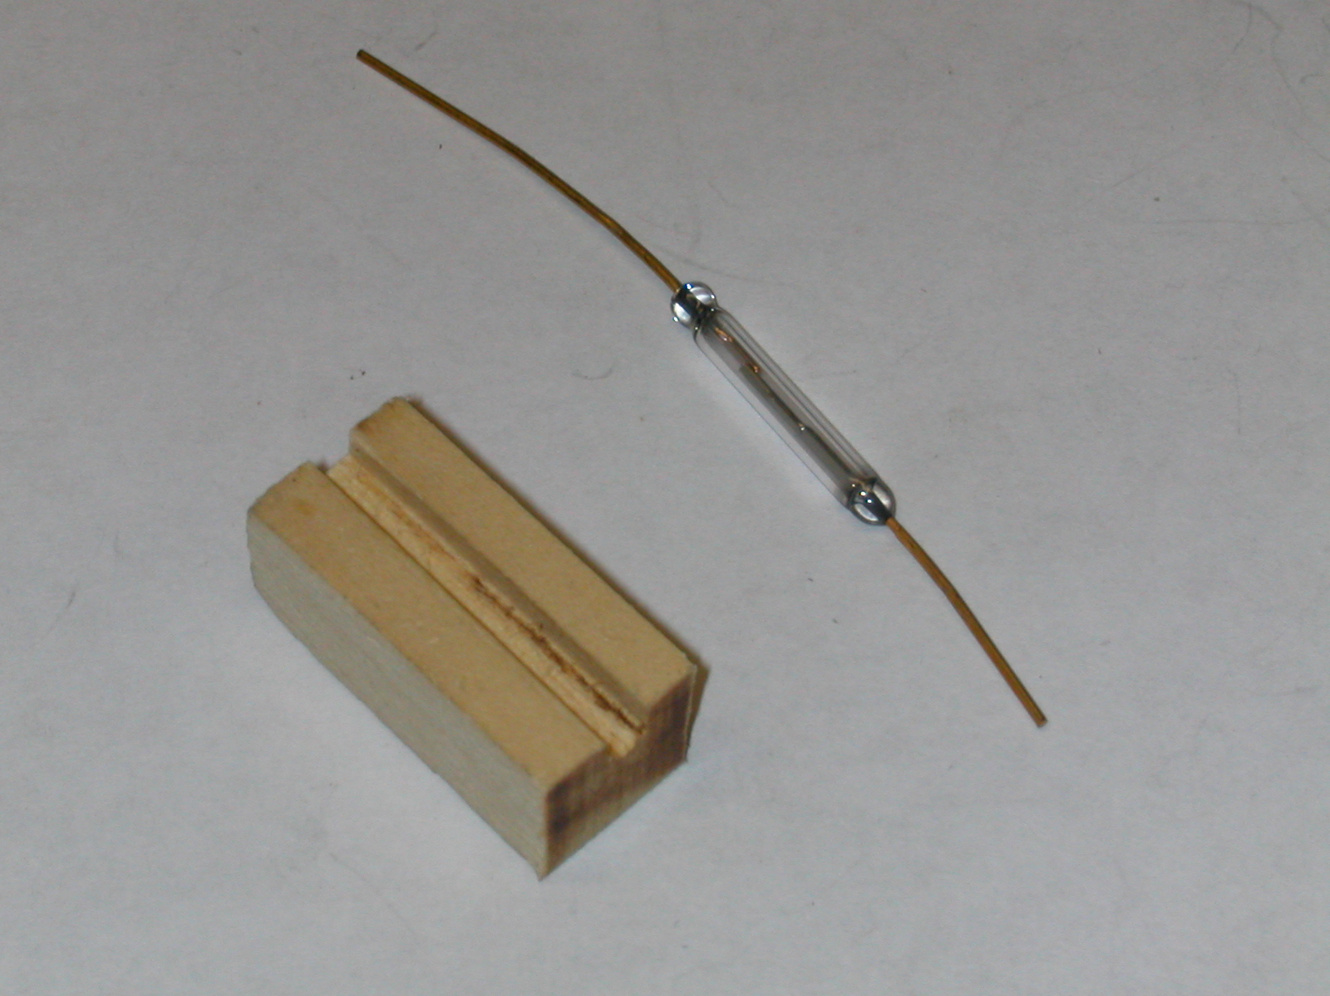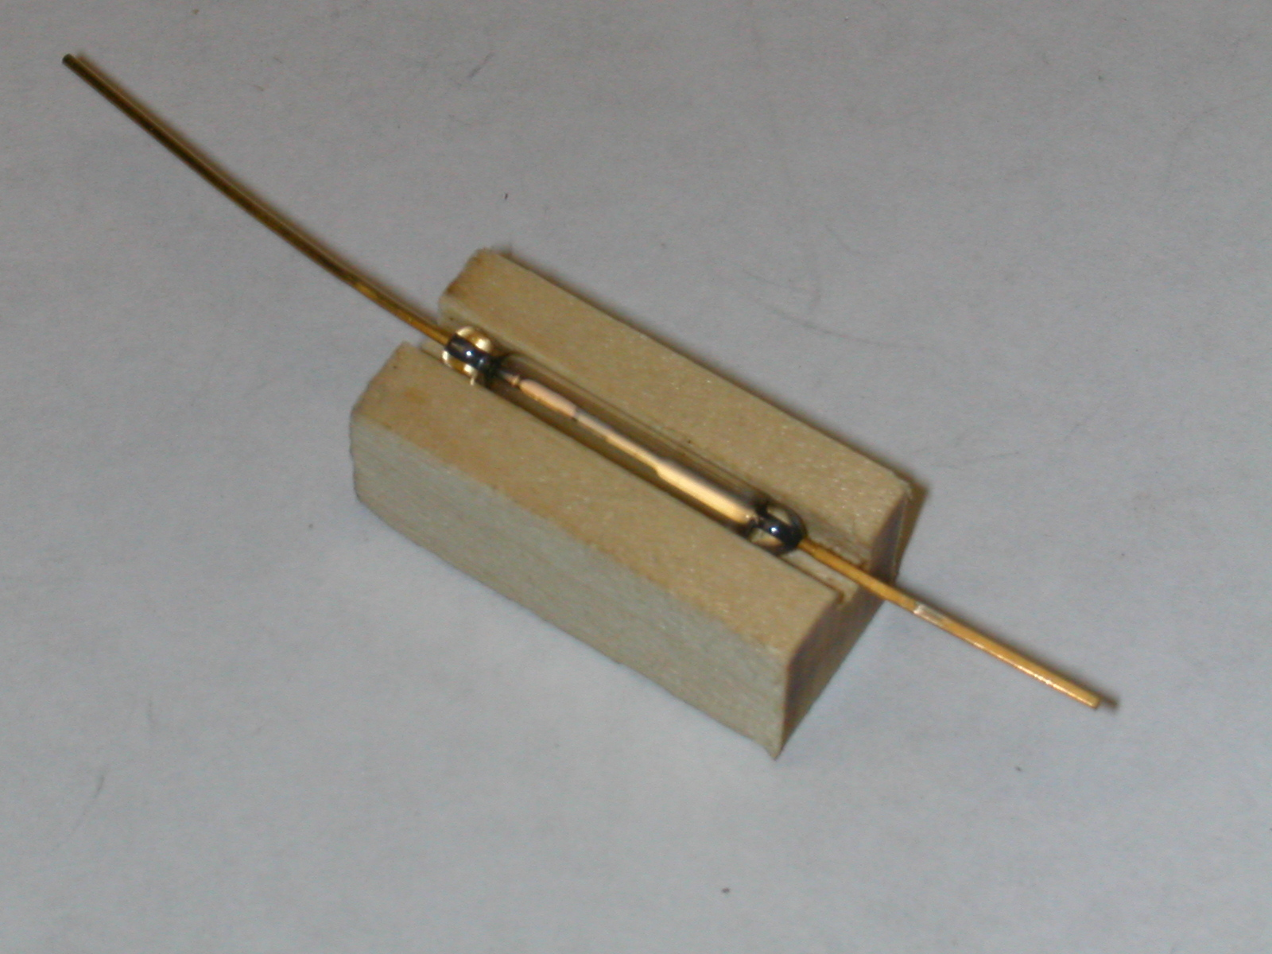
If you need to bend the leads on the reed switch, as I have in the prototype, make sure you grip the wire coming from the glass with a pair of pliers and bend the wire beyond the pliers. If you try to bend the wire by holding the glass in your hand you are sure to break the glass of the reed switch.

Magnet Placement
I placed magnets by gluing one small cylindrical magnet to a piece of Plexiglas that is just long enough to be held down by adjoining ties. I put the Plexiglas under the track and add additional ¼” magnets to make a stack that comes within ¼” of the reed switch. This arrangement works well!
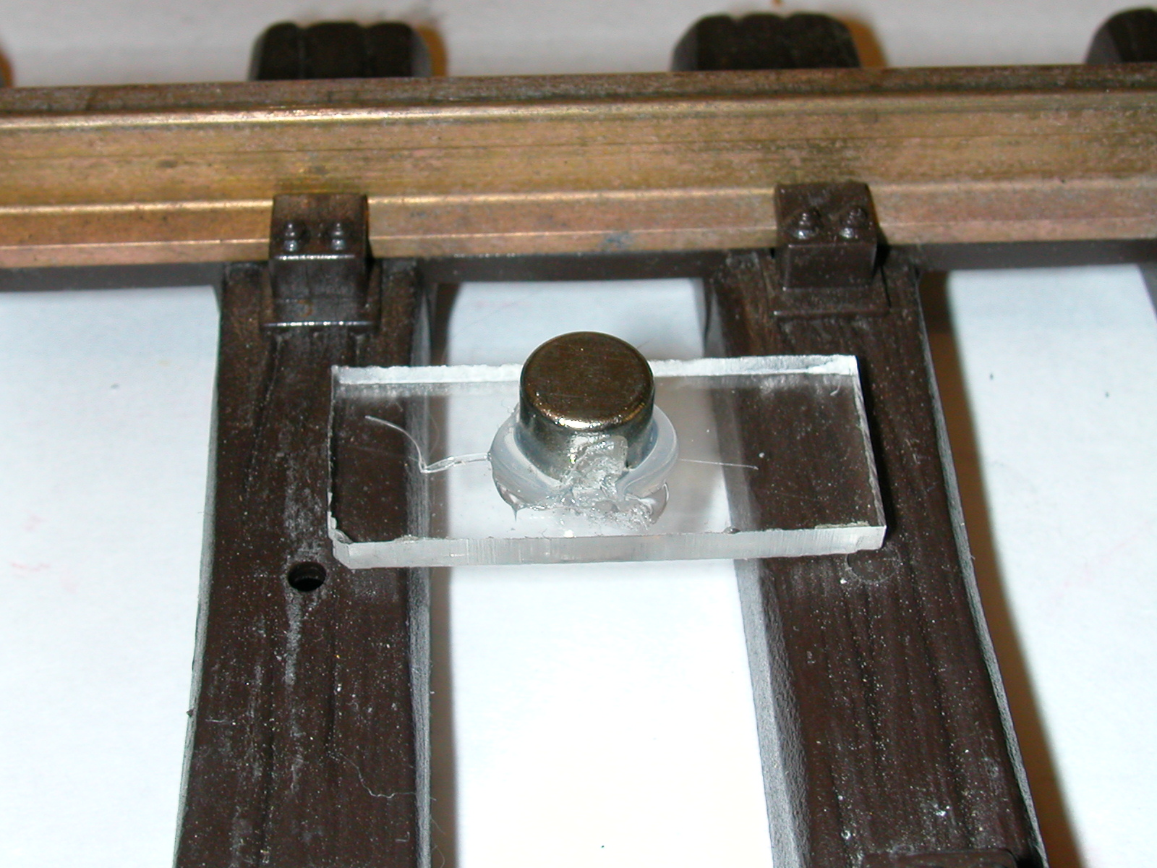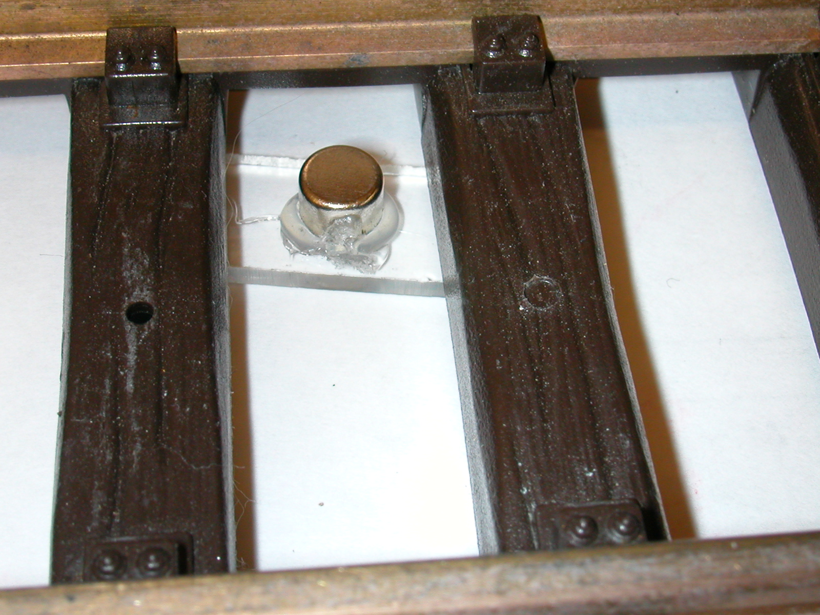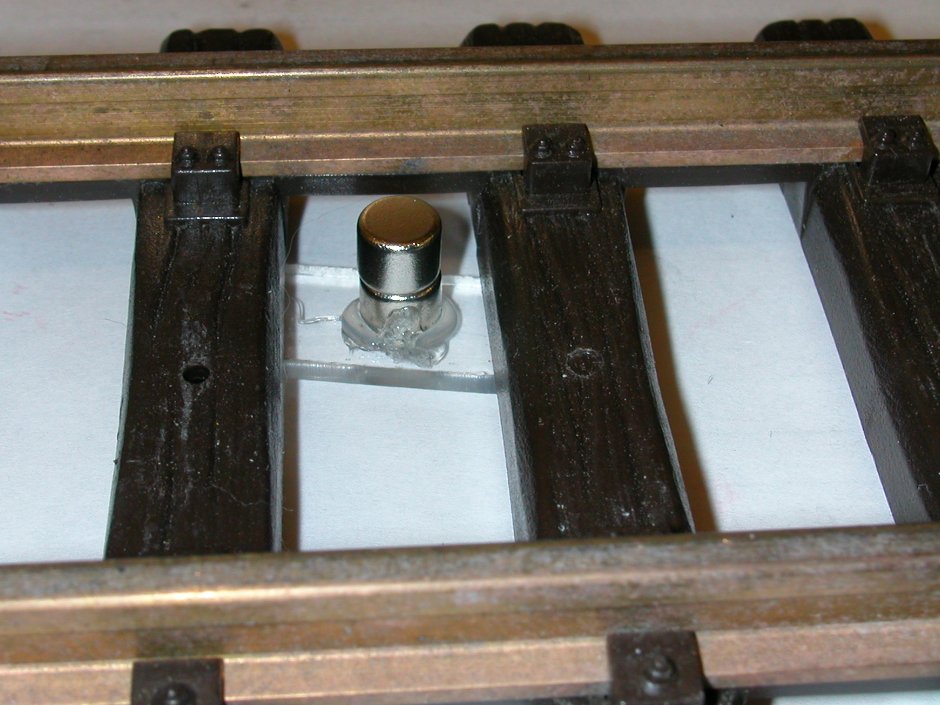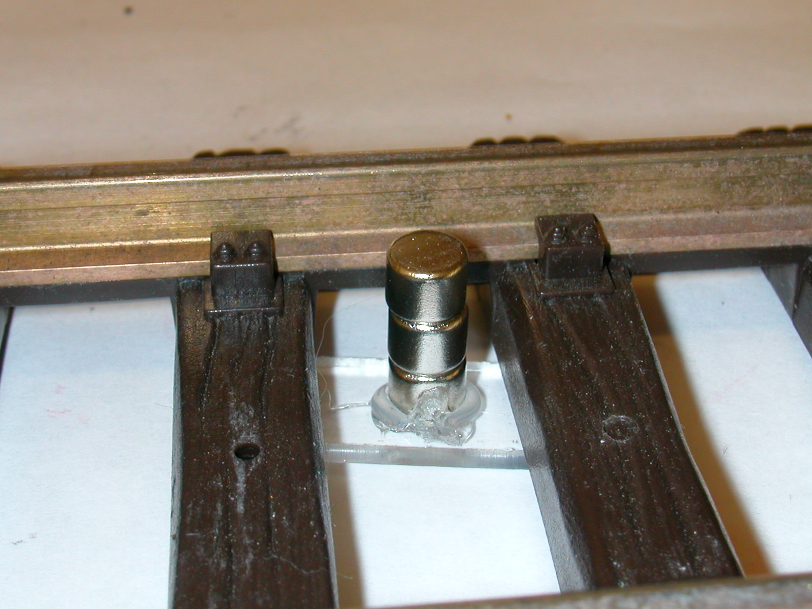

Troubleshooting

1. Killing electrical noise from motors
Since we are using a single power supply (one set of batteries) to power both the motor and the microprocessor it is possible that some electrical interference, generated by sparks within the motor, will get back to the microprocessor. Capacitors are the best way to filter out this noise. The 10 mfd tantalum capacitors that I have used have been sufficient to suppress noise in the 3 engines I have tested. If you find your system operating intermittently or randomly resetting you may need to add more suppression. Adding 220 pf capacitors between each terminal on the motor and its case can help a great deal. (see the photo)

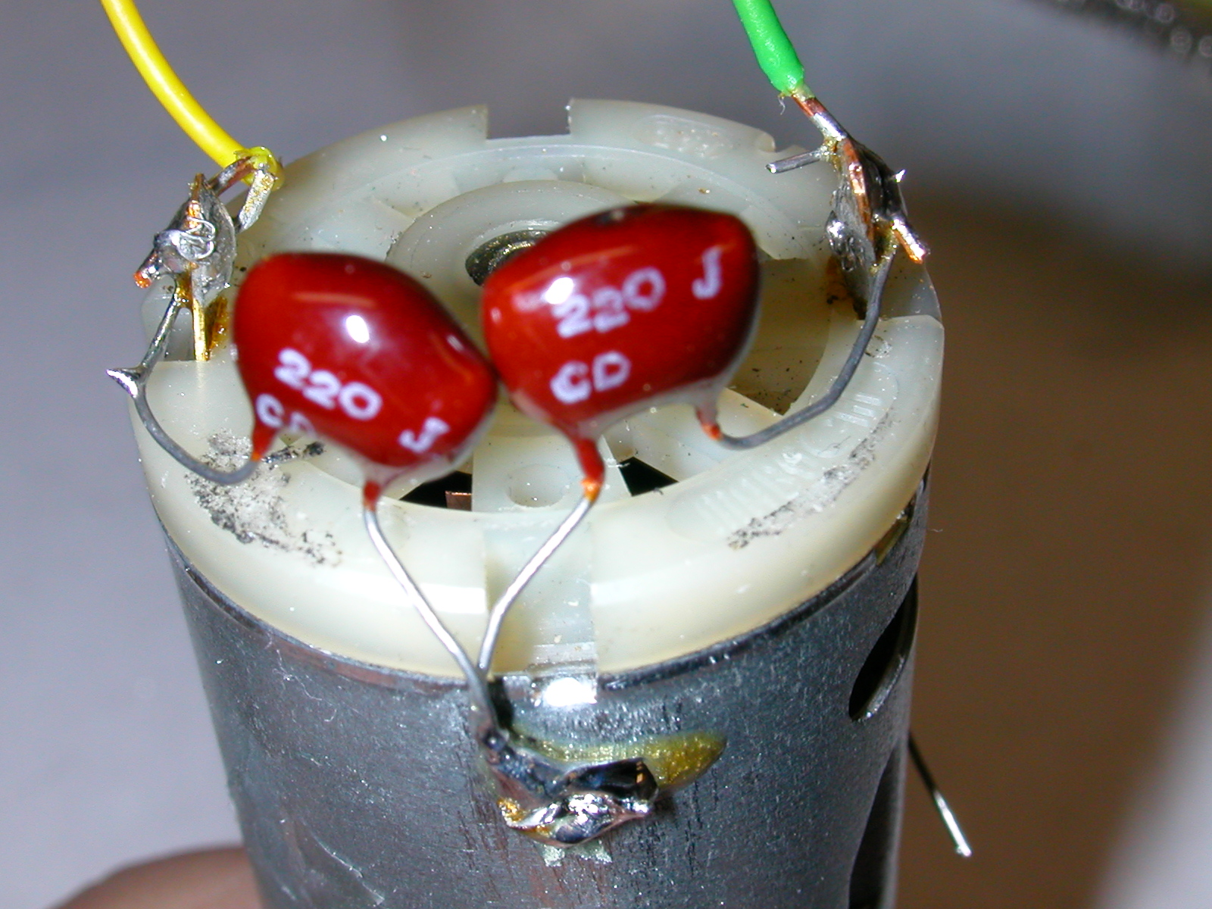
2. Setting PWMOUT variables for different motors
The PWMOUT command uses two arguments, period and duty cycle. In the programs I have used 124 as the value for the period and changed the duty cycle with the variable in the for/next loop. You may need to experiment a bit with the period value to suit your engine’s motor. To simplify this process you can try this program. It changes the period and duty cycle based on the position of the speed and delay pots and uses the debug window to display their values. Just adjust the two pots to get a good speed range and smooth running motor. Once you find a value for “period”, b2, that you like change the “symbol period” setting in the program accordingly.

'MOTOR test #2 d. bodnar 04-08-04
'used to adjust period and duty cycles to minimize "noise" coming from motor
'124 works well as period
symbol L293D1 = 1 'output - L293D direction pin
symbol L293D2 = 2 'output - other L293D direction pin
symbol pulse = 3 'output - pin for pwm
symbol toppot = b0 'read pot for top speed
symbol period = b2 'variable for period from adc
symbol duty_cycles = w3 'top of accelerate for/next
symbol temporary = w4

high l293d1:low l293d2 'spin in one direction
start:
gosub get_toppot: 'read setting from top speed potentiometer
pwmout pulse,period, duty_cycles 'send pwm pulses
goto start:

get_toppot:
readadc 2,toppot 'get pot value for max speed
duty_cycles=toppot*4 'scale to max of 1023
readadc 1, period 'get period value from pot
temporary=period*4
if duty_cycles > temporary then fixit:
debug toppot 'show value in debug window
debug period 'show value in debug window
debug duty_cycles
debug b2
return
fixit:
duty_cycles=period*4
return

Ideas for Enhancements
Below are some ideas for enhancements to the system. The Picaxe is capable of much more than just reversing an engine. Let me know if any of these ideas are of interest to you or pass along ideas of your own. They are all possible with minor modifications to the hardware and/or software.

- Add a 3rd potentiometer for acceleration rate - The original board only had places for two pots. Adding an additional pot allows you to modify the acceleration rate without reprogramming. Alternatively you could set the top speed in the program and use the top speed pot to change acceleration rate.

- Use an unused output pin to turn something on or off on the engine or train – By adding a transistor switch you can easily control devices like a smoke generator or bright light on an engine. An appropriate transistor switch can control a very high current load.

- Add a 2nd reed switch – There are holes and solder pads on the board and circuitry on the schematic to support a 2nd reed switch. This could be placed under the engine, opposite the existing reed switch, and used to activate some other event, such as creating a sound, turning lights on/off or activating the smoke generator.

- Add a buzzer to sound when magnets are encountered – While developing this project I found it useful to have an auditory cue that a reed switch had passed a magnet. There are solder pads on the bottom right of the board labeled “buz” for this purpose. You can insert a piezo buzzer (Radio Shack # 273-074) in these holes. Make sure you observe polarity by placing the + lead in the hole closest to the “z” in “buz” and the – lead in the other hole before soldering. Each time the reed switch passes a magnet a sound will be heard. Note that this happens regardless of what the program is doing.

- Add additional LEDs – there is space to add two additional LEDs to the board by the header pins labeled LED 5 And LED 4 – additional 470 ohm resistors will need to be added to activate these LEDS. Once more LEDs are available additional commands can be added to the program to give more detailed feedback on what is going on in the program.

- Use Random settings for pauses – the Picaxe has a random number generation capability. This could be used to have the engine stop for a random time (say between 10 and 200 seconds) rather than always stopping for the same time. Similarly a random top speed could be used rather than always having the engine cruise at the same speed. The random function could be used to skip over some magnets some of the time, but not always. Something to keep your guests guessing!

- Add a simple sound board to an output pin - You could easily connect an unused output pin on the Picaxe to a separate sound generating board. A recent article in LSOL (Using Pre-made Electronics, Apr 14, 2004) shows how to make such a device.

- Create a multiple magnet route plan – Rather than just using magnets to reverse your engine the program could be modified to slow and stop at any number of stations or buildings along your track. Stops could be for random times (see above) and some could be set as places to reverse.

- Check for derailment – if your engine has at least two power pickups on one side of the engine you could wire them to an unused input pin on the Picaxe and test periodically for a circuit between them. If the circuit is broken you could assume a derailment and shut down the motor. Not a bad way to run a railroad!

- Getting rid of heat - Adding a heat sink to the “H-bridge” will allow it to dissipate much of the heat that is generated as it approaches its 2 + amp capacity. The simplest heat sink is just a piece of copper or brass soldered to pins 4, 5, 12 & 13, the ground pins on the chip. In the photo you can see a bit of the white heat sink grease between the copper and the chip that helps to transfer heat. You can also add a small CPU fan from an old PC. Align it so that it blows directly on the chip & heat sink and it will operate all day at its rated capacity. I used such a fan on a computer controlled Christmas Trolley that ran in front of my house throughout the month of December and never had a problem with heat.

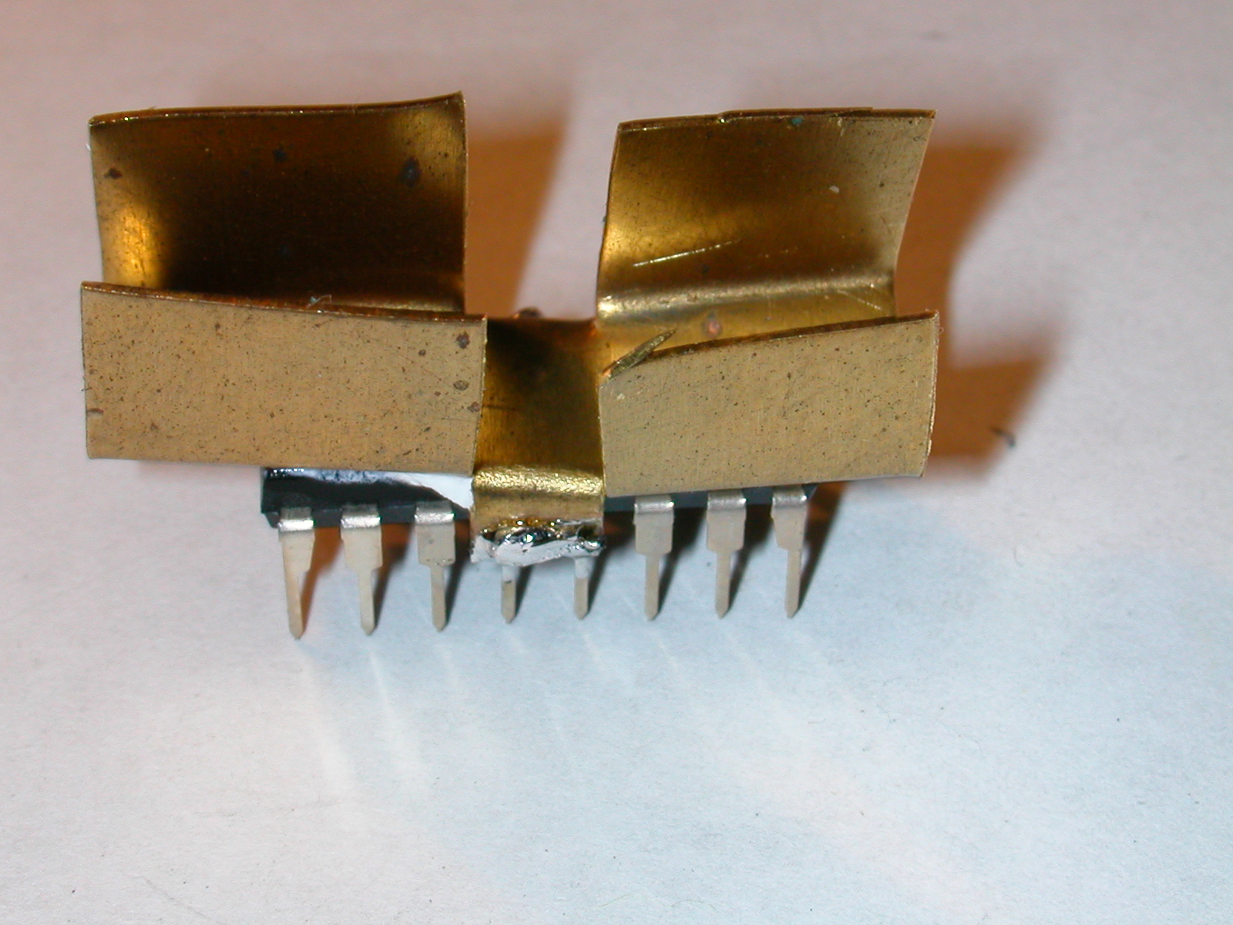

- More Power! - If you are into “More Power”, like Tim Allen on Home Improvement, here is something that you can do to operate bigger motors on bigger locomotives. You can stack a second “H-bridge” chip, piggy back style, on top of your first chip to double the current capacity. Just align one atop the other and carefully solder the pins of the top chip to the bottom one, being careful to align the chips pin 1 to pin 1, pin 2 to pin 2 and so on. (see photo) Make sure you also use a heat sink and fan if the motor draws anything close to the 4 + amp capacity of this setup.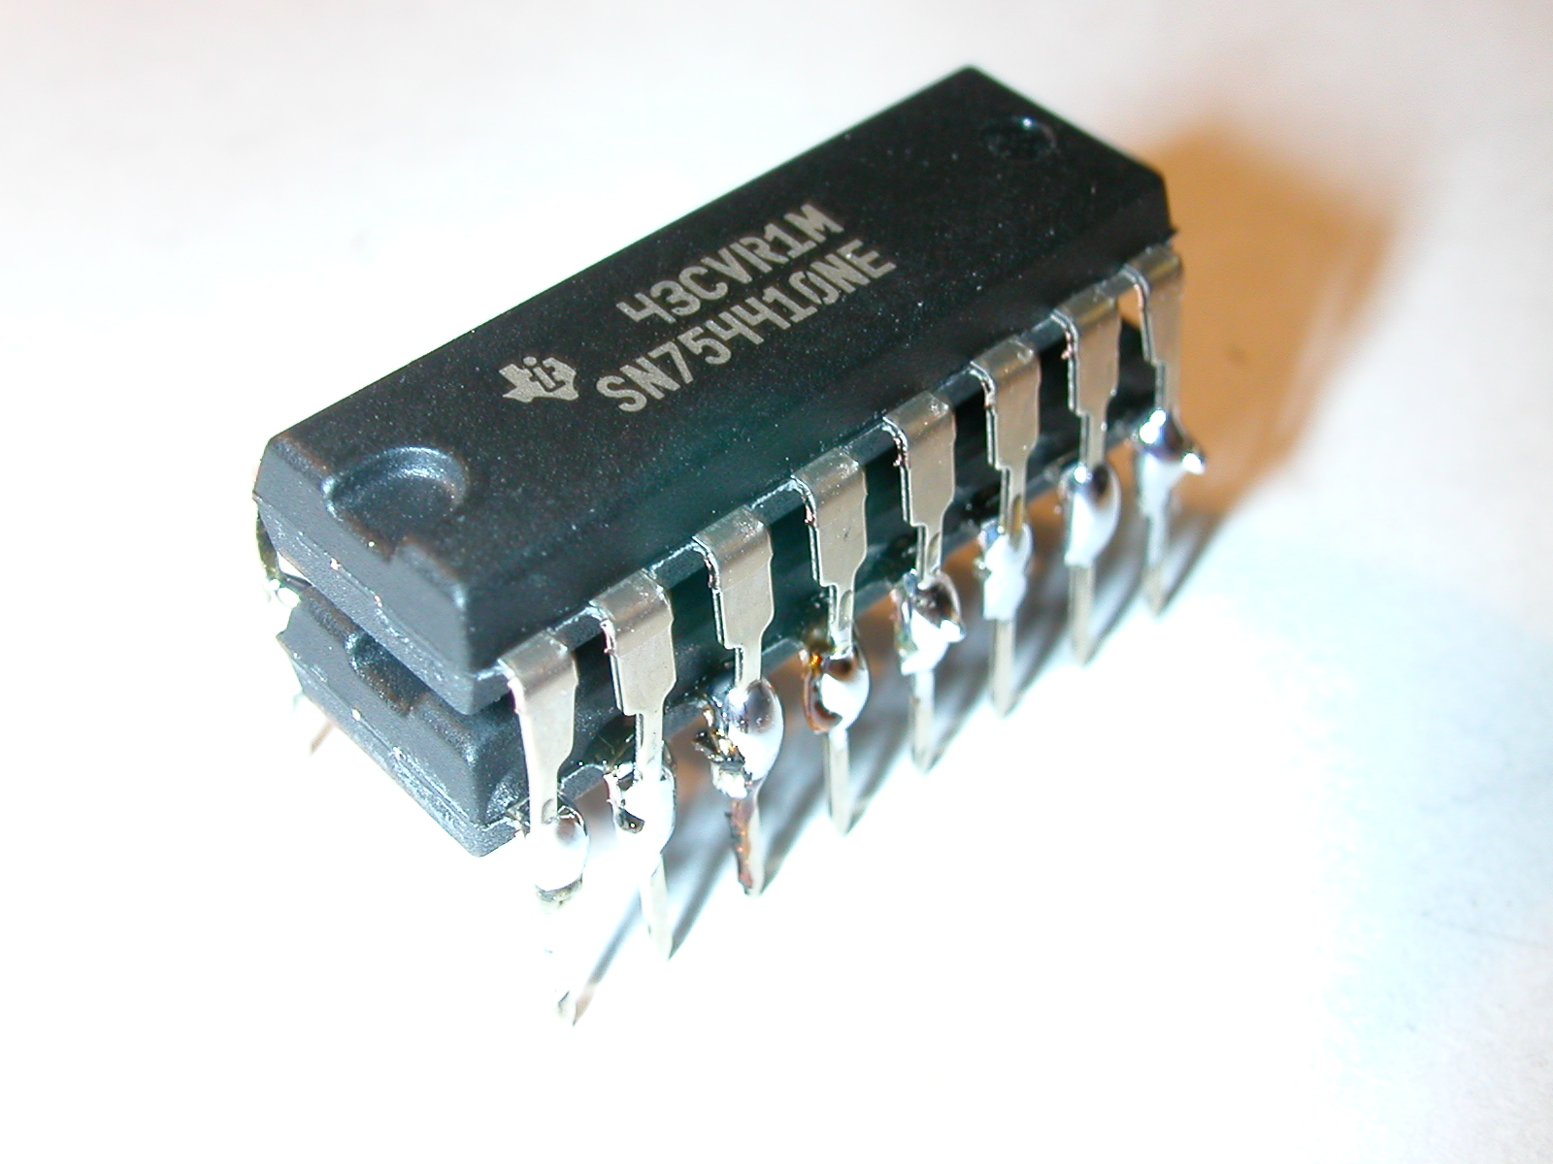

- Electromagnets rather than fixed on the track – if you replace one or more of the track mounted permanent magnets with a small electromagnet you could have a track-side event signal the train to stop or reverse. For example, you could connect the electromagnet to a semaphore on a station to signal the train to stop for passengers. If it is up the magnet is energized and the train stops, if down the train keeps on going.

Now for your ideas!

I hope that this project gives you enough information to consider building your own, custom train control system. The “store bought” units are great but there is something about doing it yourself! Good luck and let me know if I can help.

